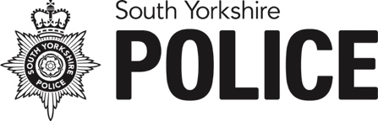
South Yorkshire Police
Picture Request Form

Email: media@southyorks.pnn.police.uk

I am applying for a photograph of the following convicted offender:
Surname:
Forename(s):
Date of Birth:
Address:
Name of police officer in the case (if known):
Charged with:
Convicted of:
Sentence (if applicable):
Volume offender? | Yes |  | No
Organisation requesting picture and contact details of person to whom it should be sent (email address):

Custody images will be released by South Yorkshire Police’s Corporate Communications department in line with the Service Level Agreement (SLA). The full SLA can be viewed on our website here.

In respect of custody images, the SLA states:

Where available, custody images held by South Yorkshire will be provided on conviction, guilty plea or sentence subject to certain conditions being met. From Monday 20 December 2021, if requested after sentencing, we will only release an image where the offender has received a custodial sentence of 12 months or more. An exception to this is if the individual is classed as a volume offender. This means they have 10 or more prior convictions of a similar nature.

It is the media’s responsibility to check whether any reporting restrictions apply that prevent the defendant from being identified.

Custody photographs remain the property of South Yorkshire Police and are supplied for single use only, to illustrate a court report. They should not be archived by media organisations. Credit should read: South Yorkshire Police.

In certain cases, where there is a substantial risk to the defendant’s life or safety, we may decline to release a custody photograph. This decision will be made by the officer leading the case.

