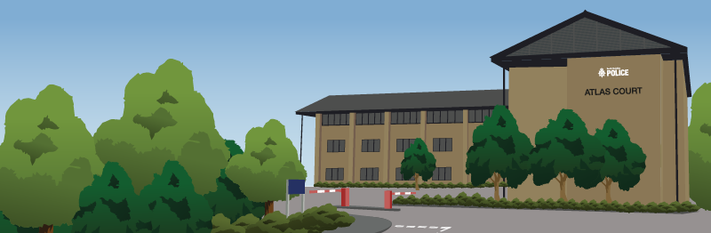

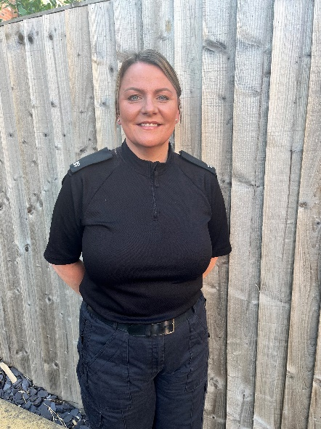
Call Handler Case Study - Vicky Heald

Did you know we have almost 400 call handler and dispatch operator roles in force? These are the staff members who work tirelessly around the clock in our Force Control Room, taking calls and crime reports before allocating incidents to our officers.

One of our call handlers and dispatch operators is Vicky, who has been in the role since 2022 after previously working in retail. While you might think that working for Boots and working for the police are worlds apart, Vicky says that she has been able to use transferable skills from her previous jobs and life experience…

“Before starting my policing career at SYP, I worked for Boots for 14 years, firstly as a dispenser, where I would dispense medication for care homes, and then as an assistant manager. I really enjoyed this role, however around six years before I started working for the force, I saw a job advert for a call handler and thought it sounded interesting and something I could possibly see myself doing. Some of my family members previously worked for the police and fire service, and I felt it was something I could continue. I considered applying for the role, however at the time I had a young family and they were my priority, so I decided to concentrate on them and promised myself that if the opportunity came up again, I would look into it.

“Fast forward to 2022 and I was no longer working for Boots. Sticking to my promise, I saw another job advert for the call handler and dispatch operator role, so I applied. I was thrilled when I found out I had passed as I had always wanted to work in a policing role where I could help people. I soon realised that many of the skills, qualities and traits you need to work as a call handler and dispatch operator were similar to those I needed to be able to do my job at Boots. As I worked in dispensing for care homes, this meant that I would often not see the patients face-to-face, which is the same as my current role as I communicate with them over the phone or via email. At Boots, my job was very much people-focused. I managed a team of staff and would often hear about people’s personal lives and had to be non-judgemental – these are all things that have transferred into my role in policing.
“With the call handling side of the role, there isn’t just a straight-forward process once the call comes through as this all depends on the nature of the call. We answer 101 (non-emergency) and 999 (emergency) calls and once a call comes through, I must assess the risk and grade the job depending on whether it requires immediate attendance or whether a visit needs to be booked in. Do we need to attend as an emergency? Does the caller need the police or another emergency service such as fire or ambulance? Once I have all the information I need, this will then be transferred to dispatch. As I have a dual role, I also take on the responsibilities of dispatch operating, where I will then allocate the incident to an officer for their attendance via the radio – this requires information to be passed clearly and concisely to the officers. We manage district queues, continually risk assess each incident, check in on them and find out if they’ve completed the job. With a dual role, I have set days where I work on the call handling side and dispatch operating side. Sometimes, I can be asked to swap mid-shift so it’s important that you can learn to quickly move between roles and multi-task when it gets busy, as you could have three different jobs running at the same time.

“Over the past three years working in this role, if someone asked me what kind of incidents stick out to me the most I would say incidents of a domestic nature. I have dealt with quite a few domestic incidents while I’ve been doing call handling, and some of these have been quite similar. We often get children calling us when their parents are arguing and it turns violent, and as a parent myself I really sympathise with the children. If I answer a call and it’s a child on the other end, I will stay on the phone with them until officers arrive. I have felt the fear from children over the phone and sometimes, I can hear what’s happening in the background. I always make sure that I try and distract them by asking what TV shows they like watching, and ensuring I’m a friendly voice for them during what can be such a traumatic time. You want them to be safe, however some children might not know their address so this can be difficult to work out their exact location. It can be emotional, however once our officers get there and get them to a place of safety, I feel so happy and relieved as I know they will be okay.

“I’m really proud of myself for taking the step into policing, and recently I won ‘FCR Colleague of the Year’ at the FCR Awards, where Force Control Room staff are recognised and praised for their work. I also won the same award at the Force Awards which shines a light on staff and officers from all areas of SYP, and I was able to take my partner and my daughter along, so it was so nice to have them there. “I would say the best thing about my role is knowing that I’ve helped someone and kept them safe from harm when they needed us. To me, every call I take is just as important as the next, and I try and provide a positive experience, especially in times of distress. It is a demanding yet rewarding job, and it is something I am extremely proud of.”

Want to join Vicky as a call handler and dispatch operator? Applications are now open so if you’re interested, you can find out more and apply on our website here: https://fa-exru saasfaukgovprod1.fa.ocs.oraclecloud.com/hcmUI/CandidateExperience/en/sites/CX_1/job/10502/?utm_medium=jobshare&utm_source=External+Job+Share



