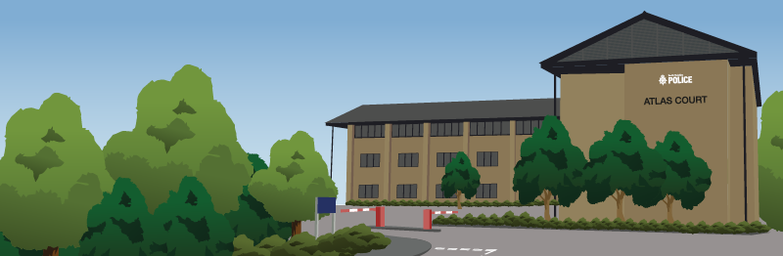

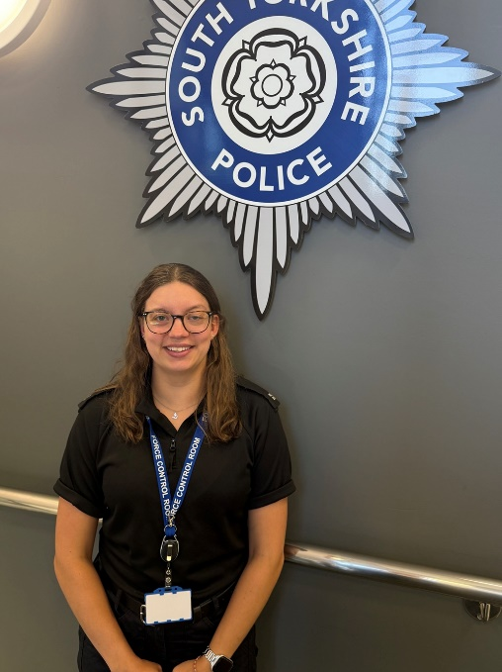
Call Handler Case Study - Megan Hughes

"I go home with a smile knowing I’ve helped others in their time of need.”

Our Force Control Room is the centralised communications centre for South Yorkshire Police, with around 400 members of staff across different departments working a variety of shift patterns. Dealing with approximately 3000 contacts per day across 999, 101 and online reporting methods, there are on average 1,200 to 1,500 incidents within every 24-hour period. Our team are trained to seek the most efficient resolution at the first point of contact, making sure officers are deployed in the most effective way possible.

Megan is one of our call handlers, and has a dual role where she will also train to become a dispatch operator which involves allocating officers to incidents once they have been reported. She explains what it's like working in the busy Force Control Room and what she enjoys about the role.

"I was first made aware of the role by my friend's mum who also works at South Yorkshire Police. She thought I would be a good fit for the role and thought I would really enjoy it. Since finishing my A-Levels in 2019, I have worked as an estate agent and more recently as an activity manager at a scout campsite. I wanted a new challenge where I could help members of the public and be able to make a difference, so I decided to apply for the role and was successful. I started in March, completed training and joined the department in June.

"The amount of calls and types of calls you take in this role differ each day - we get lots of calls from members of the public reporting both non-emergencies through 101 and 999 emergencies where sometimes, you could be back-to-back with emergency calls whether these are updates relating to an ongoing or serious incident or lots of separate emergencies. Some calls can be straight-forward in relation to what is required from us, whereas others require you to dig a bit deeper to find the most appropriate solution, but it is super rewarding when you can help get to the bottom of an incident.

"Non-emergency calls can vary from reports of missing people, which are a priority for us, to reports of domestic-related incidents, to victims of crime requesting an update on an ongoing investigation. With emergencies, I once received a 999 call in relation to a burglary that had just happened where the caller's car was stolen. I had to carry out several tasks at once; I needed to get the officers straight out to the scene, put a marker on the caller's car as well as arranging for crime scene investigators (CSI) to attend the scene to gather forensic evidence. With incidents like this, you need to have good multi-tasking and prioritisation skills as you need to be able to do various things at once as well as making your own judgement on what task to carry out first, all while talking to the caller to get all the information you need.

"We often see different call types coming in on different days or times of the week. For example, we receive a lot of emergency calls during weekends, when people go out on Friday and Saturday nights. Often these calls can be reports of a disturbance or fight. All calls are risk assessed in the same way, but a call of this nature requires quick thinking and lots of questions to get the required information as quickly as possible i.e. is the suspect still at the scene? Are there any weapons involved? Is anyone injured? We also sometimes get calls through to 101 and it then transpires the call is actually an emergency - again quick-thinking and decision-making is essential.

"To be able to do this job, there are several skills you need to have; multi-tasking, prioritisation, problem-solving, working under pressure and having good communication and listening skills to name a few. Sometimes, callers can get irate or upset, which can be distressing for the call handler as well. You need to be able to calm the caller down while obtaining the information you need to help them and take control of the situation, while also empathising with them and being that friendly, helpful voice at the other end of the phone when they need you.

"There are so many things I enjoy about this role - every call is different and sometimes, calls can change very quickly and you have to think on your feet; there isn’t a call script to follow. You also have to be confident in your decision-making, however, you do receive incredible training which equips you for the role.

"The work/life balance is really good as we work a four on, four off shift pattern. Having four days off is great! The holiday allowance is also really generous; outside of work I enjoy travelling, exploring new places and experiencing new cultures, and this job allows me to do that as taking one set of four shifts off gives you 12 days off in a row. I had previously worked nights before but had never done a 12-hour night shift, so that was a new adjustment I had to make as part of my daily routine when on shift. If I'm doing a night shift, I make sure I get plenty of rest during the day (this might sound a bit daunting to some people, however I've found blackout blinds and earplugs really help!) The 12-hour night shifts can be tough, especially if you're working a 7pm – 7am shift - towards the end of the shift when it’s less busy and most of your colleagues have gone home, it can be challenging to power through, but I would definitely recommend some sugary snacks to help you get through the night!

"While the job can be difficult sometimes, everyone looks out for one another which I think is really important due to the nature of some of the calls we can receive. As a group, you become a family and the friendships you make will stay with you for life.

"I’m so happy I took the step into this job and would recommend anyone that is thinking of doing it to apply. The atmosphere in the Force Control Room is great, and the job is very rewarding - I often go home with a smile on my face knowing I’ve helped others in their time of need."

Does this sound like something you'd be interested in doing? We're currently recruiting for call handlers and dispatch operators as part of a dual role. If you're interested and want to find out more and apply, visit our website.



