
Chief Constable of South Yorkshire
Statement of Accounts 2025/26
(unaudited)


Contents

1. CHIEF CONSTABLE’S INTRODUCTION | 2. WRITTEN STATEMENTS AND CHIEF FINANCE OFFICER NARRATIVE REPORT | 3. CORE FINANCIAL STATEMENTS | 4. NOTES TO THE ACCOUNTS | 5. POLICE PENSION FUND ACCOUNT & NOTES | 6. GLOSSARY AND CONTACTS
Chief Constable’s Introduction  Page 4 | Chief Finance Officer  Page 17 | Comprehensive Income and Expenditure Statement  Page 38 | Supporting the Core Financial Statements  Page 43 | Police Pension Fund Account and Notes  Page 95 | Glossary of Terms  Page 98
Annual Governance Statement  Page 6 | Independent Auditor’s Report  Page 32 | Movement in Reserves Statement  Page 39 | Supporting the Comprehensive Income and Expenditure Statement  Page 51 |  | Acronyms and Abbreviations  Page 101
 | Statement of Responsibilities for the Statement of Accounts  Page 36 | Balance Sheet  Page 40 | Supporting the Movement in Reserves Statement  Page 69 |  | Contact Information  Page 102
 |  | Cash Flow Statement  Page 41 | Supporting the Balance Sheet  Page 72
Supporting the Cash Flow Statement
Page 89
Other Notes
Page 92

The Statement of Accounts for South Yorkshire Police for the year ended 31 March 2026 has been prepared and published in accordance with the Accounts and Audit Regulations 2015 and the Code of Practice on Local Authority Accounting in the United Kingdom 2025/26 (“the Code”) issued by the Chartered Institute of Public Finance and Accountancy. The Code is based on International Financial Reporting Standards, as adapted for the UK public sector under the oversight of the Financial Reporting Advisory Body.


Sheffield Peace Gardens
1. Introduction

Chief Constable’s Introduction

INTRODUCTION TO THE 2025/26 STATEMENT OF ACCOUNTS BY THE CHIEF CONSTABLE



This Statement of Accounts sets out the financial position of the Force at a time of significant challenge, but also of clear strategic intent. It reflects the decisions we are taking to unlock the ambitions of the force within our financial constraints.

Central to that ambition is a renewed and explicit focus on problem solving. By placing problem solving at the heart of our operating model, we aim to tackle the underlying causes of harm, reduce repeated and avoidable demand, provide better and more sustainable support to victims, and ease the cumulative strain placed on our workforce. This approach is essential if we are to meet rising and increasingly complex demand while maintaining public confidence and protecting the wellbeing of our people.

The financial environment in which we operate remains exceptionally difficult, and the choices required to achieve a balanced budget have not been straightforward. Nevertheless, financial sustainability is fundamental to delivering our long-term priorities, enabling investment in prevention and problem solving, and ensuring that the Force remains resilient in the face of future pressures.

As we look ahead, we now await the outcome of Police Reform. We hope that this will provide greater clarity and stability, and help shape a framework that better supports forces to plan for the long term, align resources with demand, and continue to innovate in the public interest. Whatever the outcome, we remain committed to using our resources responsibly, transparently and in a way that delivers the greatest possible benefit for the communities we serve.



Lauren Poultney

Chief Constable for South Yorkshire during 2025/26

Chief Constable’s Introduction (continued)

ORGANISATION CHART 2025/26

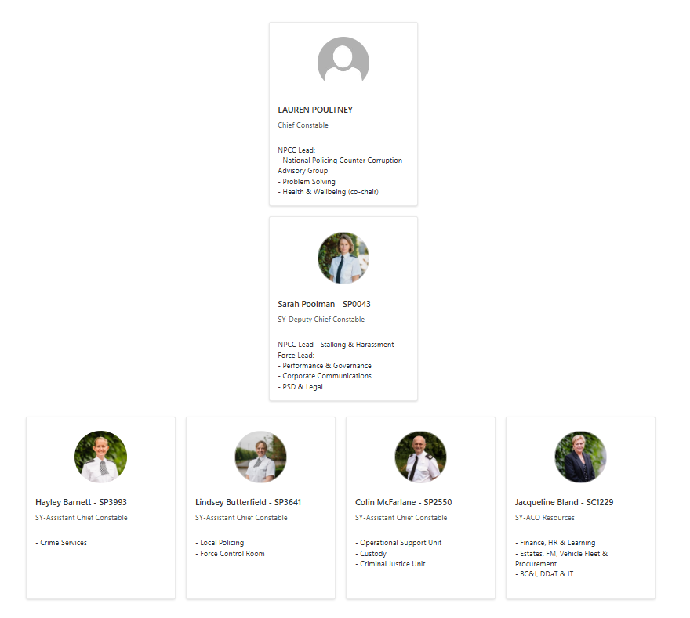
Annual Governance Statement
INTRODUCTION

The Governance Framework within SYP reflects the principles of the CIPFA ‘Delivering Good Governance in Local Government: Framework’ and the associated ‘Guidance Notes for Policing Bodies in England and Wales’, both published in 2016 with a May 2025 addendum issued for updates (the CIPFA / SOLACE Framework).

The CIPFA / SOLACE Framework requires local authorities to publish an Annual Governance Statement, and to be responsible for ensuring that:
- their business is conducted in accordance with all relevant laws and regulations
- public money is safeguarded and properly accounted for
- resources are used economically, efficiently and effectively to achieve agreed priorities which benefit local people.

The system of internal control is a significant part of the Governance Framework and is designed to manage and reduce risk to a reasonable level. It can, however, provide only reasonable and not absolute assurance of effectiveness. The system of internal control is a continuous process, designed to identify and prioritise risks to the achievement of the SYMCA’s policies, aims and objectives, to evaluate the likelihood and impact of those risks being realised, and to manage them economically, efficiently and effectively.

As two distinct corporations sole, the SYMCA and CC each had responsibility for conducting, at least annually, a review of the effectiveness of their individual governance arrangements. The reviews are informed by: consideration of the Assurance Framework for risk, governance and internal control; the work of Internal Audit; the work of the Joint Independent Audit Committee (JIAC); other assurance panels’ activity; and the managers within both the SYMCA and South Yorkshire Police (SYP). It is also informed by the comments received from external auditors and other agencies, taking account of the improvements identified.

The diagram illustrates the “core principles” underpinning the CIPFA/SOLACE Framework and how the various principles for good governance relate to each other. Principles A and B permeate implementation of principles C to G. The diagram also illustrates that good governance is dynamic, and that an entity as a whole should be committed to improving governance on a continuing basis through a process of evaluation and review.

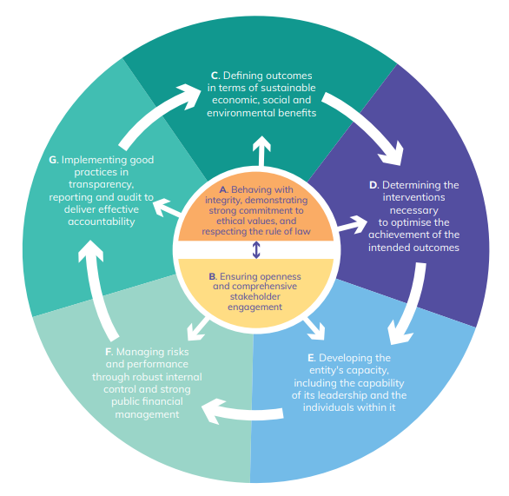

Annual Governance Statement (continued)

SOUTH YORKSHIRE POLICE GOVERNANCE MEETING ARRANGEMENTS
ASSURANCE PANELS | FORMAL ARRANGEMENTS | PARTNERSHIPS &  COLLABORATION  GOVERNANCE
INDEPENDENT ADVISORY PANEL FOR POLICING PROTESTS (IAPPP)  Focus: SYP’s policing of protests from planning and community engagement to the de-brief and learning, particularly focused on how the policing of protests impacts on local communities’ trust and confidence in the police  INDEPENDENT ETHICS PANEL  (IEP)  Focus: police legitimacy, ethics, equality diversity & standards  JOINT INDEPENDENT AUDIT COMMITTEE (JIAC)  Focus: risk, governance, internal control, VF M & integrity of financial systems | SENIOR COMMAND TEAM BUSINESS MEETING  STRATEGIC CHANGE BOARD FUTURES BOARD  QUARTERLY PERFORMANCE REVIEWS PEOPLE BOARD  STRATEGIC ENABLING BOARD CAPITAL MANAGEMENT BOARD  STRATEGIC SYSTEMS BOARD ORGANISATIONAL LEARNING BOARD  FORCE PERFORMANCE DAY STRATEGIC DEMAND BOARD  COLLABORATION EFFECTIVENESS BOARD JOINT ACCOUNTABILITY BOARD  CHIEF CONSTABLE | SAFEGUARDING BOARDS  COMMUNITY SAFETY PARTNERSHIPS  CHIEF CONSTABLES’  OPERATING BOARD  SOUTH YORKSHIRE POLICE & FIRE COLLABORATION BOARD

Annual Governance Statement (continued)
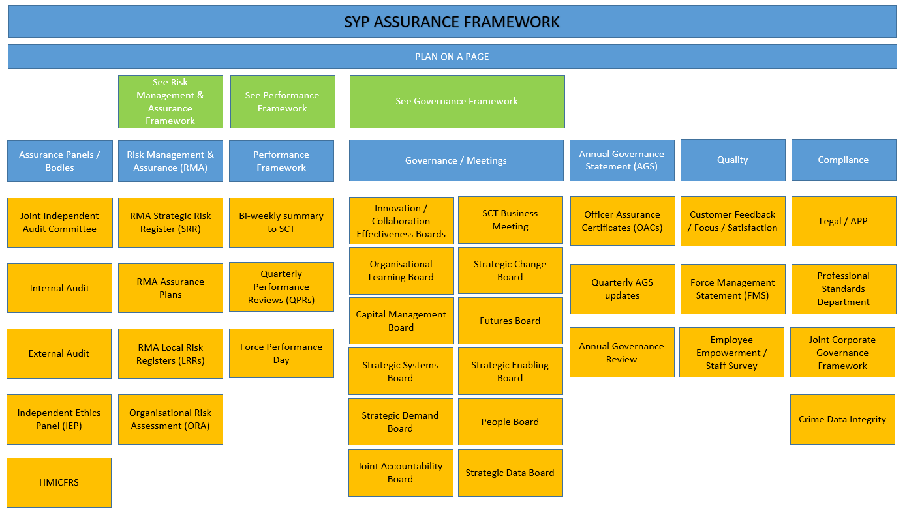

Annual Governance Statement (continued)

OUR ASSESSMENT OF EFFECTIVENESS

The Chief Constable for South Yorkshire Police is responsible for maintaining the King’s peace and has direction and control over the officers and staff operating within South Yorkshire Police. The Chief Constable holds office under the Crown and is appointed by the Mayor of South Yorkshire Police. The Chief Constable has a professionally qualified Chief Finance Officer (CFO). Under the Police Reform and Social Responsibility Act 2011, the South Yorkshire Police CFO has a personal fiduciary duty by virtue of their appointment as the person responsible for the proper financial administration of South Yorkshire Police. The Chief Constable’s CFO is a key member of the Chief Constable’s Chief Officer Team. The CFO is actively involved in, and able to bring influence to bear on, strategic business decisions of the Chief Constable and ensure immediate and longer term implications, opportunities and risks are fully considered. The CFO leads the promotion and delivery by the Chief Constable of good financial management so that public money is always safeguarded and used appropriately, economically, efficiently and effectively. The CFO ensures the Finance function is resourced to be fit for purpose and oversees that appropriate management accounting systems, functions and internal controls are in place so that finances are kept under review on a regular basis.

The Force governance framework reflects the principles of openness, integrity, accountability and equality and supports the delivery of quality policing. It enables the Force to monitor the achievement of its strategic objectives and to consider where those objectives have led to the delivery of appropriate, cost-effective services, including achieving value for money. The Force also has effective governance meetings and assurance framework in place to support the governance reporting and processes. These are effective internal controls to help ensure that objectives are achieved that promote economical, efficient and effective use of resources and that the assets and interests of the Mayor are safeguarded.

The Police and Crime Plan sets out the resourcing of the Police and Crime Plan priorities and performance indicators. It reflects the areas of greatest importance locally, identified through extensive consultation with the public, or where performance improvement is required. The Force works collaboratively with Partners to help deliver this plan.

The annual review of the effectiveness of the CC’s assurance arrangements for risk, governance and internal control (the review) is carried out by the Senior Command Team (SCT) and involves the consideration of information from a variety of sources, including the CC’s developing assurance framework, annual governance review and senior officer statements of assurance. The review determines, amongst other things, whether any ‘significant governance issues’ are identified. For the purposes of the annual review, ‘significant governance issues’ are defined as:

- An issue which has prevented or seriously prejudiced achievement of a principal objective
- An issue where additional funding has had to be sought in order to resolve it
- An issue which has resulted in a material impact on the accounts
- An issue which the Head of Audit and Risk has specifically highlighted in the annual audit opinion
- An issue which has attracted significant public interest and has damaged the reputation of the Mayor and/or South Yorkshire Police
- An issue which has resulted in formal action being taken by the Chief Finance Officer.

Annual Governance Statement (continued)

One of the key assurance statements, in reviewing effectiveness, is the annual report and opinion of the Head of Internal Audit. The Head of Internal Audit reported to the Joint Independent Audit Committee that the Chief Constable has a framework of governance, risk management and controls that provides limited assurance regarding the effective and efficient achievement of objectives. A range of issues in relation to key control areas included IT Resilience, Staff Onboarding, Health and Safety, Financial Controls audits. Further control weaknesses were identified in the Health and Safety, Staff Onboarding and the Oracle System review.

The 2024/25 Auditor’s Annual Report identified one significant risk in relation to governance although this related to SYMCA for MRP to secure value for money and one improvement from audit work (one from audit work and two from VFM review in 2023/24). The Force changed auditors in 2025 for 2024/25 accounts to KPMG and communication is ongoing to further strengthen the working together and governance arrangements for the forthcoming year.

The July 2025 HMICFRS PEEL assessment highlights South Yorkshire Police as an ambitious, high-performing force with significant improvements in protecting vulnerable people, tackling domestic abuse and neighbourhood policing. The Force performed well across many areas of the inspection framework, particularly when compared to similar forces. The Inspectorate rated the Force as good in two areas, adequate in six areas and requires improvement in two areas.

The Force’s Plan on a Page (see page 20) is also a key document in meeting the principles of good governance. It sets out our culture, values and behaviours, how we deliver priorities and the focus for the Force.

Other sources used in the annual review of governance include the business continuity arrangements for the Force which ensure robust plans are in place to respond to any crisis as required. The Force ensures it is covered by strong insurance arrangements to minimise financial risks and to ensure processes are in place. Financial Instructions are reviewed and updated at minimum annually to ensure they remain fit for purpose. A Medium Term Financial Strategy is in place and is fully linked to the organisation’s strategic objectives. Robust monitoring takes place at operational level in terms of regular budget monitoring along with management of income collection and debt recovery.

The Force complies with relevant laws and regulations, ensures staff are fully trained and supported. Good governance is not only about processes, rules and procedures but should also demonstrate the spirt and ethos of good governance.

The Local Code of Governance (the Local Code) guides the Force of how to conduct business, in the best interests of the public, to make South Yorkshire a safe place to live, learn and work. The transfer from the former PCC to SYMCA has brought the opportunity to review the internal governance of SYP and this forms the basis of a project that will take place early in 2026/27. This will assess decision making protocols, current Board configurations and financial frameworks and approvals to ensure effective controls
and efficient decision making.

Ongoing developments including the strengthening of the Oracle Cloud system for finance, HR, procurement etc has continued during 2025/26 and will continue in the new financial year along with Priority Based Budgeting (PBB) to enable the Force to support the MTRS and help with the deficit of funding over the next few years.
The assurances within this document demonstrate the governance arrangements in place are good and operating effectively. All recommendations that are received through Internal Audit, External Audit and HMICFRS are tracked and monitored. While both the financial and operational areas are challenging, the Force is confident that appropriate governance arrangements are in place and operating effectively.

Annual Governance Statement (continued)

WHERE OUR GOVERNANCE NEEDS TO IMPROVE

The Force carries forward the outstanding governance issues from the previous year. These are monitored on a quarterly basis at SCT and JIAC. The Annual Governance Statement action plan is presented at JIAC with an overview of what the issue is, proposed actions, responsible officer, timescales, update and status (RAG rated). At a minimum, each quarter, these are discussed formally at SCT and a review during the meeting of whether any new governance issues need to be added. This includes a review of where core arrangements are not operating effectively and where significant, these are added to the governance action plan.

A review of the Officer Assurance Certificates (OACs) has been undertaken and there were 4 key highlights as follows. These have been assessed as not being a significant governance issue to the Force and therefore improvements will be led by the Heads of Departments.

- Due to the implementation of Oracle Cloud in October 2024, this caused disruption to a number of financial and HR areas including financial reporting, access to data, authorisation of spend, lack of integration to other systems. Work has been ongoing post go-live to resolve the challenges in relation to reporting and information to meet stakeholder expectations.
- HR improvements required in relation to obtaining role profiles, availability of leadership courses, structures not being updated on the system, how establishment and strength, vacancy and recruitment will be managed.
- Feedback has been received in relation to IT windows 11 laptops, mobile telephony connectivity, asset replacement of systems approaching end of life and difficulty with the stability of a couple of systems.
- Data Management – improvements suggested in relation to data security, along with clear processes, procedures in relation to specific access of systems, sharepoint and one drive.

The Force has also recognised the need to improve governance of decision making and clarity with SYMCA, to ensure the requirements of both legal entities are met.

HOW WE HAVE IMPROVED OUR GOVERNANCE ARRANGMENTS IN 2025/26

During 2025/26, there has been 4 areas that the Force has been working through on improving governance arrangements. There were no new significant governance issues identified within the year. Post 2025/26, internal controls and compliance have been added to the strategic risk register regarding the concerns raised about internal controls and compliance as highlighted in numerous Azets reports.

The following significant governance issue was closed at the end of the financial year – Body Worn Video

Annual Governance Statement (continued)

Issues during 2025/26 | Action taken
Case File Preparation | SCT have directed the Commanders to review their case file strategy, use of Dashboards and Governance. Reminders that where identified by District Command, officers are signposted for bespoke training via the CJU File Preparation Supervisors.  Learning has been reviewed and the selection process for the Sergeants’ promotion boards will include case file quality competence assessments.  New Action Plan Dashboard has been devised to improve compliance, reduce escalations and support supervisors in proactively managing demand, which improves visibility and compliance of action plans.  Additional support from CPS has been received to attend police stations to support office via DA clinics offering valuable cross agency observational learning. The DA scrutiny panels have proved very beneficial, good considerations and best practice identified.
IT Service Delivery | The IT service review business case has been approved by both forces, and all formal governance has been completed. Implementation activities are underway with an anticipated go-live in summer 2026.  In the interim the IT service delivery remains strong against the agreed Key Performance Indicators, with effective governance measures still in place between the two forces and IT to manage concerns and opportunities.
Body Worn Video Significant Data Loss | OnTrack have completed their analysis of the BWV recovery work, which has identified a significant gap in data that is not available for recovery. The result of this means that the core data is not available despite best efforts to recover the files. As a result, governance and measures have been put in place and strengthened to mitigate any future loss of data and implementation of lessons learnt as a result. This has been reported to the Joint Internal Audit Committee and agreed to be discharged as at the end of March 2026.
Subject Access Request compliance | Significant work has taken place to reduce the backlog, however, SYP has had resourcing implications with staff leaving as well as sickness within the team.  A peer review took place in November 2025 which identified key learning to implement in 2026/27.  Temporary resourcing has been approved to extend 3 temporary Disclosure Officers for a further six months.

Annual Governance Statement (continued)

For 2026/27, the 3 governance areas remain where action remains to be taken.

Issues for 2026/27 | Planned Action
Case File Preparation | The following actions will support the force in embedding sustainable improvement and ensuring compliance with investigative and disclosure standards:  - Accelerate rollout/embedding of ERO training and refresher training;  - Strengthen supervisory capacity;  - Drive officer engagement with RTCC & EIA;  - Ensure Connect post-charge visibility is prioritised;  - DDaT to support action plan dashboard/email notifications;  - Develop a detailed implementation roadmap;  - Embed stronger quality assurance processes;  - Strengthen feedback loops;  - Report progress monthly.
IT Service Delivery | Implementation activities are underway with an anticipated go-live in summer 2026 for the Hybrid model.
Subject Access Request compliance | To continue to work on the backlog of cases which is to bring all outstanding cases back within a sub 6 month position.  To continue with training to enable multi-skilled staff across FOI and SAR functions for Q4 2026/27.  To embed the new staff within the team following the extension of 3 temporary Disclosure Officers for a further 6 months to help with the demand.

In addition to the governance issues, the Force has a robust Risk Management process which monitors high level strategic risks, local risks and assurance plans for 6 areas within the Force. All risks are monitored at least quarterly, reported to the SCT and JIAC. Any new strategic risks are reviewed to determine if these require adding to the governance register. Risk Management within the force is one of the pillars that helps demonstrate governance by applying the principles to identify, assess, manage and communicate risks, ensuring strategic goals are met. It integrates risk appetite with decision-making, requiring a proactive culture of transparency and collaboration within the Force. Risk Management is fully embedded into the business including the business planning process to identify the threat, harm and risk facing the Force to prioritise and identify areas which need resourcing. Details of the top strategic risks can be found later in the narrative report.

The national focus on Police Reform continues the expectation of Force collaborations as opportunities to deliver efficiencies and enable greater productivity. These arrangements require overarching joint governance to ensure parties risks are effectively managed. There is likely to be a requirement on forces for ongoing monitoring and this will need further governance to be reviewed in terms of the risk/opportunity of bringing forces together and combining governance processes.

Annual Governance Statement (continued)

EXECUTIVE SUMMARY FOR 2025/26

The Force has continued to progress and improve its governance arrangements during the year. SCT reviewed the Annual Governance Statement regularly throughout the year and a report was completed quarterly which highlighted progress made, identified any new issues and made recommendations to discharge issues where appropriate. Updates were provided to the Joint Independent Audit Committee on a quarterly basis following the SCT business meeting.

Districts and Departments governance arrangements have been monitored during the year through the Force Risk Management and Assurance Framework and Officer Assurance Certificates (OACs) were reviewed at the end of the year for each business area to ensure positive arrangements were in place and no significant weaknesses were identified.

The Collaboration Effectiveness Framework continues to be developed to ensure that the force is monitoring and managing its collaborations and achieving value for money.

Horizon scanning is undertaken and fed into the Strategic Demand and Productivity Board to enable a proactive response to legislative or government changes. Thematic leads and business leads are linked into regional and national programmes, which ensures the force is responding to consultation and learning at the earliest opportunity. All of this is captured in the Force Management Statement.

The Force continued to build on the work of the Futures Board. The force produced the document ‘South Yorkshire – Our Future Operating Environment’ which articulates what the future operating environment will look and feel like and this has been refined and evolved during the year. This forms part of the basis for the Force to continually develop understanding of what the future may hold and most importantly how this will influence its actions to better prepare for or influence the future in relation to its assets, capability, plans and strategies. The Futures Board includes partners such as the Yorkshire Ambulance Service and South Yorkshire Mayoral Combined Authority.

The CC is confident that they are compliant with the CIPFA Financial Management Code and this will remain an area of continuous improvement over the next year.

The Force continues to abide by the principles of good governance in line with the CIPFA/SOLACE Framework and to provide various sources of assurance. The Force remains committed to maintaining and where possible improving these arrangements by addressing the issues identified by Internal Audit, enhancing performance to focus on key risks and areas to develop and improving the services for the public.

In the financial year 2026/27, we propose to take steps to improve our governance arrangements.

We will monitor implementation and operation of these improvements during the course of the year through the Chief Constable’s Senior Command Team and feed this into the next annual governance review. Overall the Force is satisfied that the governance is fit for purpose but in the financial year 2026/27, will take steps to further improve and strengthen our governance arrangements.

Annual Governance Statement (continued)



  Lauren Poultney | 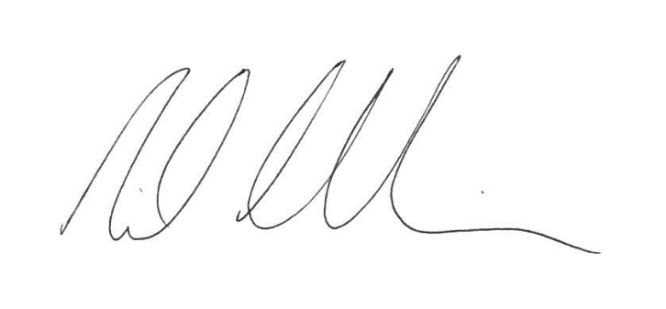  Neil Chamberlain FCPFA
Chief Constable | Chief Finance Officer

23 June 2026 23 June 2026


2. Written Statements

Barnsley Town Hall


Chief Finance Officer Narrative Report

SOUTH YORKSHIRE AS A PLACE

South Yorkshire consists of the four local authority areas of Barnsley, Doncaster, Rotherham and Sheffield, covers 599 square miles and has a mixture of both urban and rural areas. The rivers running from the Pennines to the west of the county supported the steel manufacturing industry with Sheffield once being the undisputed iron, steel and cutlery capital of the world. The County has a number of areas of deprivation concentrated within what were, originally, the mining communities and some of the urban areas of the city and townships.

The County has a population of just over 1.43 million (Office for National Statistics 2024) with 10.0% from a minority ethnic background (Census 2021). The elderly population is expected to rise significantly over the next few years and the residential population is supplemented by university students and the large numbers who visit, socialise in, commute into, or travel through the County each year. The transport infrastructure includes major rail stations.

SOUTH YORKSHIRE POLICE AREA

SYP is the sixteenth largest of the forty-four forces in England, Wales and Northern Ireland (from Government Statistics for Police Workforce September 2025). The Force is divided into four policing districts, which are co-terminus with the Metropolitan Boroughs. In addition, the Force has central departments that provide specialist support services such as Operational Support Unit and Crime Services, which deal with threats, posed by public disorder, firearms, child abuse and organised crime, whilst being responsible for planning around civil emergencies. These services, whilst less visible than front line policing, have been integral to meeting the SYMCA’s strategic policing priorities and the Force’s operational objectives.

FINANCE DEPARTMENT
This year has continued to be challenging with the team continuing to learn, develop and implement changes to the Force’s ERP system. I am pleased that we have made significant improvements to the quality and timeliness of budget planning and monitoring. Despite the challenges and reduced resources within the Financial Accounts team, the accounts have continued to be streamlined and completed within timely deadlines.

Neil Chamberlain FCPFA,
Chief Finance Officer,

Section 151 Officer

23 June 2026

About South Yorkshire

Sheffield (population 582,493)  Key Facts:  - Area of 142 square miles  - M1 Motorway  - Fourth largest city in England *  - Major sporting and entertaining venues including English Institute of Sport – Sheffield and Utilita Arena Shefield  - Major universities  - Meadowhall shopping centre  For more details on Sheffield visit the Council website at:  www.sheffield.gov.uk  * per population data Office for National Statistics 2024 | Doncaster (population 319,765)  Key Facts:  - Area of 219 square miles  - M18 Motorway and A1(M)  - Frenchgate shopping centre  - Doncaster Racecourse  - The Dome leisure centre  For more details on Doncaster visit the Council website at:  www.doncaster.gov.uk
Rotherham (population 276,595)  Key Facts:  - Area of 110 square miles  - M1 Motorway  - Parkgate shopping centre  - Magna Science Adventure  For more details on Rotherham visit the Council website at:  www.rotherham.gov.uk | Barnsley (population 251,770)  Key Facts:  - Area of 127 square miles  - M1 Motorway, Dearne Valley Parkway (A630)  - Glass Works  - Alhambra shopping centre  - Barnsley Civic Centre  For more details on Barnsley visit the Council website at:  www.barnsley.gov.uk


About South Yorkshire (continued)

The mid 2024 population data for South Yorkshire as provided by the Office for National Statistics is as follows:

Age Groups | Barnsley | Doncaster | Rotherham | Sheffield | Total
0-9 | 27,915 | 36,725 | 31,742 | 63,037 | 159,419
10-19 | 28,865 | 37,804 | 33,541 | 72,213 | 172,423
20-29 | 27,147 | 34,992 | 30,870 | 100,167 | 193,176
30-39 | 35,444 | 45,692 | 38,534 | 82,862 | 202,532
40-49 | 29,437 | 38,356 | 32,628 | 66,626 | 167,047
50-59 | 35,596 | 42,417 | 37,311 | 68,363 | 183,687
60-69 | 31,072 | 38,840 | 32,320 | 57,576 | 159,808
70-79 | 23,585 | 28,897 | 25,218 | 43,860 | 121,560
80-89 | 10,751 | 13,477 | 12,212 | 23,094 | 59,534
90+ | 1,958 | 2,565 | 2,219 | 4,695 | 11,437
Grand Total | 251,770 | 319,765 | 276,595 | 582,493 | 1,430,623

The total population for White British and Black & Minority Ethnic (BME) groups in 2021 (from Census) is as follows:

Area | Barnsley | Doncaster | Rotherham | Sheffield | Total
Total Population | 244,572 | 308,104 | 265,806 | 556,523 | 1,375,005
% White British | 96.9% | 93.1% | 91.0% | 79.1% | 90.0%
% Black & Minority Ethnic | 3.1% | 6.9% | 9.0% | 20.9% | 10.0%

Chief Finance Officer Narrative Report (continued)

The Force’s ‘Plan on a Page’ sets out how the Force will deliver on the SYMCA’s Police and Crime Plan.

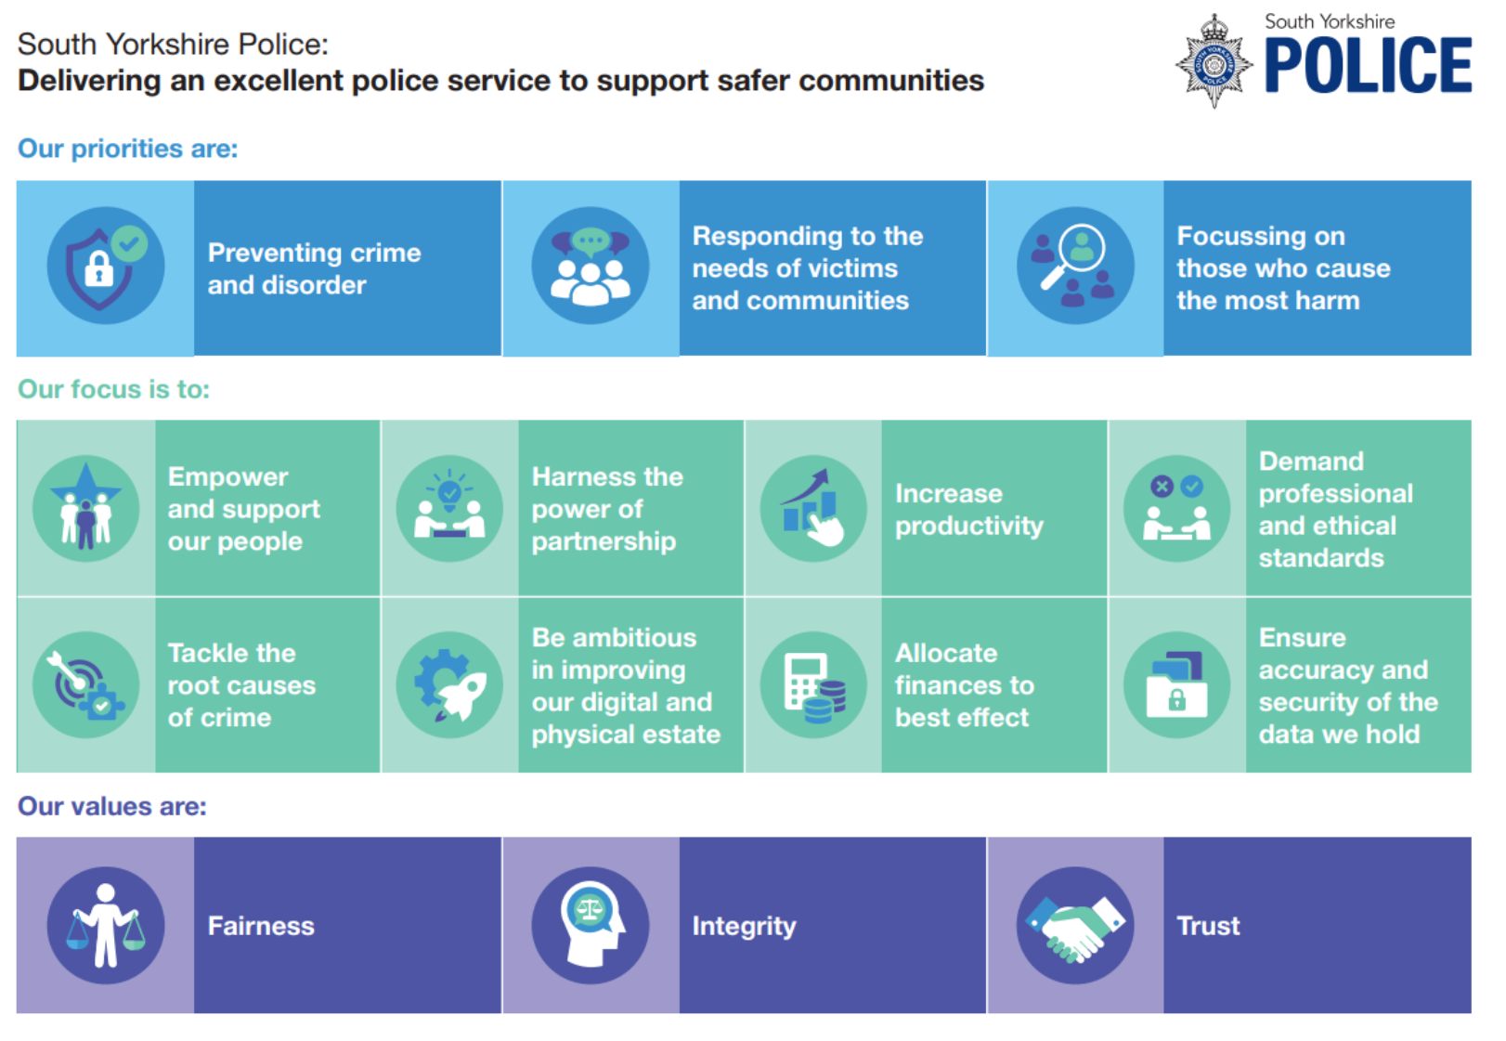
Chief Finance Officer Narrative Report (continued)

THE FORCE’S PERFORMANCE

Achievements 2025/26

Over the last year, the Force has:

- The force is compliant with the Best Use of Stop and Search (BUSS) scheme. Between April 2025 and March 2026, the force carried out 12,177 stop searches. Of these, 31 per cent had a positive outcome and in 27 per cent the object of the search was found. The main items found continue to be drugs and stolen property.

- During 2025/26, 95 per cent of 999 calls were answered within ten seconds, compared to 93 per cent in 2024/25.

- The force recorded 145,614 crime investigations in 2025/26 compared with 149,613 in 2024/25, a reduction of 2.7 per cent.

- The force has recorded a 13 per cent reduction in Neighbourhood Crime when comparing 2025/26 to 2024/25. Including a reduction of 21 per cent for Burglary, 15 per cent for Theft from Person, 12 per cent for Robbery and 8 per cent for vehicle crime.

- The volume of investigations resulting in action taken during 2025/26 was 15.3 per cent (compared to 13.4 per cent in 2024/25), and diversionary activities were applied in a further one per cent of investigations.

- There were 143,813 investigations finalised within South Yorkshire in 2025/26. Of these, over 20.5k investigations lead to action best being taken against an offender (14.3 per cent). This is an overall charge rate of 10 per cent, caution rate of 1 per cent and community resolution rate of 3 per cent and is a consistent increase against previous years.

- Burglary victims reported satisfaction levels of 82 per cent during 2025/26.

- Offences involving firearms reduced by 16 per cent in the 12 months to December 2025 compared to the previous 12-month period (from 137 to 115).

- Between April 2025 and March 2026, 83 per cent of all domestic abuse victims were satisfied with the service provided by the force and 70 per cent of victims of crime (sampled from victims of residential burglary, vehicle crime, hate crime and vulnerable victims) reported they were at least fairly satisfied with the whole experience.

- In 2025/26, 51 per cent of all contact has been through 101 calls, followed by 999 calls (39 per cent). Online reporting (9 per cent) and web chats (1 per cent) are extending in their reach, but the public preference currently remains the telephony route. The average wait time for 101 calls has also continued to improve. The average time in Q4 2025/26 was 1 minute and 42 seconds.

- The Force attended 91 per cent of burglaries in the most recent financial quarter (Jan-Mar 26).

- Both Emergency and Priority response times have improved when comparing 2025/26 to 2024/25. The percentage of emergency incidents responded to within 15 minutes has increased from 77 per cent to 80 per cent. The percentage of priority incidents attended within one hour has increased from 55 per cent to 62 per cent.

- The Force has developed inclusion training which has been rolled out and delivered to all officers, staff and volunteers before September 2026.

- Roll out of Naloxone to Police Officers as a rapid initiative to combat rising drug-related deaths. This is carried by officers to provide immediate, life-saving aid while waiting for paramedics.

Chief Finance Officer Narrative Report (continued)

- The Force has continued with Operation Duxford which is a recurring, high-visibility initiative to combat crime in local communities, featuring targeted arrests, drug seizures, vehicle recovery, and community engagement. It brings together numerous officers and partners to address issues like burglary, vehicle crime and ASB based on local intelligence.

- The Force has introduced a new, technology-led performance framework designed to improve the effectiveness of neighbourhood policing and better monitor against local and national priorities. The framework, which aligns with the Police and Crime plan 2025-2029, aims to drive up standards by tracking detailed data on neighbourhood activities.

- Wellbeing roadshows are focused on providing health checks, mental health support and wellbeing resources. These include employee wellbeing, Trauma Risk Management, resources focused on mental health and resilience. The initiatives also include public health roadshows providing free health checks, advice using the NHS app along with related event such as Spring Wellness Day and Wellbeing Walks.

- Doncaster Central Neighbourhood Policing Team (NPT), along with its partners, won the national Exemplary Partnership Award at the 2026 Resolve ASB Awards for outstanding efforts in tackling antisocial behaviour. The award recognised the team’s work in collaboration with the City of Doncaster Council and the Frenchgate Shopping Centre. ​

- The force has maintained its commitment to Climate Action, launching the SYP Climate Plan which is a key document outlining our framework for achieving our targets. The plan includes 25 actions for 2025/26 and our progress has been widespread and significant. Achievements in 2025/26 included further investment in energy efficiency and renewable energy technologies across our estate; developing a new tool for embedding sustainability in estate projects; securing funding for EV chargers via the Depot Charging Scheme; installing further EV charging infrastructure (30 new sockets over 10 sites); and working in collaboration with Emergency Service partners as part of a funded project, to scope our transition to EV using modelling software.

- The sustainability team sustained its focus on efficiencies and savings and installed a number of water meters to reduce billing errors and expedite leak detection. We improved our process for managing waste enquiries and utilised our in-house waste service with our dedicated team member and e-van, to launch a number of collection and disposal services all reducing waste expenditure and/or generating income.

- We continued to prioritise partnerships as a sustainability priority, collaborating and partnering with other emergency services to ensure best practice. The sustainability team maintained active membership of the Emergency Services Environment and Sustainability Group; attended regular meetings with regional and national blue light colleagues; and participated in several meetings and events with a range of public and private sector partner organisations.

- The force maintained engagement with colleagues around sustainability via both formal and informal channels and our Sustainability Impact Lead (SIL) network continued to grow with colleagues receiving training, regular newsletters and drop-in sessions. The force hosted its annual sustainability conference and the 2025 event saw SILs come together to share learning and ideas, and take part in beekeeping and beeswax crafting experiences.

Chief Finance Officer Narrative Report (continued)

- South Yorkshire Police generated 213 tonnes of general waste during 2025/6 (a 20% reduction on the previous year), achieved a 45 percent recycling rate (up from just 30% in 2024/25), and continued to ensure a 100 percent diversion of general waste from landfill via an ‘Energy from Waste’ site. In 2025/26, our waste generated enough energy to power 67 average UK homes for a year!

- In year savings target exceeded by £1.0m. Achieved savings of £4.4m against a target of £3.4m.

Chief Finance Officer Narrative Report (continued)

FINANCIAL PERFORMANCE

CORE FUNDING

The 2025/26 Police Finance Settlement was announced in December 2024 with the Government increasing the grant by £14.6m to £276.1m including pensions and uplift grants (£261.5m in 2024/25).

ADDRESSING FUTURE CHALLENGES

The Medium-Term Resource Strategy has recently been updated, indicating that, for a variety of reasons, the Force expects to see increasing demand for services. To balance the budget and the gap, the Force has invested in a savings and efficiency programme which has some dedicated resources to develop a plan to address this. The Force has also committed to continuing the Priority Based Budgeting process which commenced in 2023/24 as part of the wider Savings and Efficiencies Programme.

In terms of predictions for long term funding, the Home Office settlement continues to be for one year only, with 2025/26 being the holding year before phase 2 of the comprehensive spending review period.

The legacy issues for the Force which include Hillsborough and non-recent child sexual exploitation present significant financial challenges, particularly in the longer term. Plans to balance the budget are reviewed on a regular basis, in order to ensure that adequate savings plans are in place, and that income is maximised whilst delivering a high standard of service to the public.
2025/26 COUNCIL TAX AND REVENUE SPENDING

The 2025/26 Finance Settlement once again provided ‘greater flexibility’ for the Mayor to raise the precept by an amount equivalent to £14 on a Band D property.

The Mayor proposed that the council tax precept for 2025/26 be increased by the maximum level equivalent of £14 for Band D properties, in accordance with the funding assumptions set by the Home Office. This represented an increase of 5.58% and produced a Band D council tax of £265.04 (£251.04 in 2024/25). As 75% of South Yorkshire properties are in Band A and Band B, this equated to annual increases of £9.33 and £10.89 respectively.

The increase in precept along with a continuing savings programme from the Chief Constable and use of £3.3m reserves resulted in a balanced budget after legacy costs. The Mayor once again applied to the Home Office during 2025/26 for Special Grant funding to meet the estimated costs of legacy issues.

The General Reserve balance of £37.5m represents about 10.51% of the net revenue budget, which exceeds prudent levels (5%). However, there remains a significant risk associated with legacy costs and the outcome of the future Home Office Special Grant funding applications which could affect the level and adequacy of the reserves in future years.

The approved budget requirement was £356.843m for 2025/26.

 | £000 | £000 | %
Budget Requirement |  | 356,843
Sources of Finance
MHCLG Funding |  | (99,033)
Police Grant |  | (145,553)
Council Tax Freeze Grant |  | (1,269)
Council Tax Support Grant |  | (9,591) | 71.6
Council Tax Income:
- Barnsley | (17,920)
- Doncaster | (23,346)
- Rotherham | (19,507)
- Sheffield | (39,352) | (100,125)
Collection Fund Surplus |  | (1,272) | 28.4
Total Financing |  | (356,843) | 100

Chief Finance Officer Narrative Report (continued)

FINANCIAL PERFORMANCE (CONTINUED)

FINANCIAL OUTLOOK
On the 2 February 2026, the Mayor approved the budget and council tax precept for 2026/27. Accompanying this was the Medium-Term Resource Strategy, Capital Programme and Reserves Strategy, which is to be followed for the forthcoming years.

The core funding (government grant) for South Yorkshire amounts to £289.8m along with precept income of £106.7m. The 2025/26 pay award has created an ongoing cost pressure of around £0.25bn in 2026/27 over and above what was budgeted for. This is the first time in recent years that the full yar cost implication of the pay award has not been met with grant support.

There are a number of factors nationally which may create pressure on budgets and which are not unique to SYP. These include reliance on precepts, technological changes, the absence of capital funding, high inflation and societal level pressures placing demand on policing services.

A number of local challenges impact SYP, including the costs borne by the Force in support of legacy issues. A number of assumptions have been made with regard to ongoing support from the Home Office. These include the ability to spread the cost of legacy issues over a longer period of time. This is assumed across all years of the MTRS but is subject to annual approval by Government.

In preparing the MTRS, different scenarios were modelled to reflect various levels of precept and government grant. The impact of changes were examined in relation to cost assumptions such as pay inflation, along with investment and savings considerations. The Home Office funding settlement gave the flexibility for the Mayor to increase the precept on Band D properties by up to £15. Given the challenges facing the Force, the Mayor determined to use this flexibility and agreed this increase to £280.04 for the year on a Band D property. This equates to an annual increase of £10.00 for a Band A property (19 pence a week).
Net assets/(liabilities)
(£2,209m)
31 March 2026

After a £15 increase, the MTRS includes use of reserves of £1.03m for 2026/27 with a continuing savings plan and use of reserves for the whole of the MTRS period.

The issues concerning the legacy of Hillsborough and non-recent CSE in Rotherham remain and during the year there has been ongoing dialogue with the Home Office in relation to funding.

The Group maintains a strong balance sheet despite financial challenges. Total outstanding borrowing from the Public Works Loan Board (PWLB) as at 31 March 2026 is £25.8m compared with the underlying need to borrow (capital financing note 23) of £154.2m. This means that at some point in the future, the Group is likely to need to borrow an additional £128.4m to ensure that the liquidity position is retained. The Group position is as follows:

Non-current assets (property and investments) £217m

Net current assets (debtors, creditors and cash) (£18m)
Funded by:

Usable reserves £84m

Unusable reserves (£2,293m)
Long term liabilities (pensions and provisions) (£2,408m)

Chief Finance Officer of Finance Narrative Report (continued)

FINANCIAL PERFORMANCE (CONTINUED)

REVENUE OUTTURN
The Force’s budget for 2025/26 was approved by the Mayor in February 2025, funded from a combination of government grant, income raised from council tax and reserves. The actual revenue expenditure for the year, after legacy costs, was £356.7m. The most significant variances are:
- Employee costs underspend of £5.2m, 1.6% due to a higher than budgeted level of staff vacancies, which partly resulted from paused recruitment in areas under review as part of the Priority Based Budget exercise.
- Premises costs includes a slight overspent and no material variances to report.
- Transport costs overspend of £0.9m, 15.6% mainly due to a higher provision for claims (£0.7m).
- Supplies and Services costs underspent by £2.4m, 7.8% mainly due to later than planned spend on projects in DDAT, IT and Facilities.
- Supports & Agency costs overspent by £1.8m, 7.7% mainly as a result of higher provisions for Public Liability costs.
- Capital Financing costs overspend as a result of using underspends in other areas to fund capital projects.
- Income overachieved by £1.8m, 11.4% as a result of additional funding for dangerous animals work (£0.7m), higher reimbursements from other public bodies (£0.5m) and higher mutual aid income from other forces (£0.3m).
- Legacy outturn as a result of no budget set as funded by the capitalisation order approved from the Home Office.

The following table sets out the revised budget compared to the actual expenditure in 2025/26. At the end of the financial year, the level of spending was less than budget.
 | Revised Budget | Outturn | Variation
 | £’000 | £’000 | £’000
Employee Costs | 326,515 | 321,325 | (5,190)
Premises Costs | 9,723 | 9,776 | 53
Transport Costs | 5,781 | 6,685 | 904
Supplies & Services Costs | 30,846 | 28,450 | (2,396)
Support & Agency Costs | 23,153 | 24,936 | 1,783
Capital Financing Costs | 669 | 5,823 | 5,154
Income | (15,700) | (17,497) | (1,797)
External Funding | (24,993) | (25,348) | (355)
Balance from reserves | (1,503) | - | 1,503
Net Expenditure Before Legacy Costs | 354,491 | 354,150 | (341)
Hillsborough Civil Claims | - | 919 | 919
Child Sexual Exploitation Civil Claims | - | 238 | 238
Operation Stovewood | - | 1,353 | 1,353
Legacy Costs | - | 2,510 | 2,510
Total Net Expenditure After Legacy Costs | 354,491 | 356,660 | 2,169

Revenue expenditure is reported in the Accounts under the Comprehensive Income and Expenditure Statement with a surplus of £34.9m. The table below shows how the revenue outturn position varies from the Comprehensive Income and Expenditure Statement:
 | £’000
Underspend as per budgeted outturn for the Force | (341)
Legacy overspend | 2,510
Net position | 2,169
Remove items included in budgeted outturn
Debt charges and impairment losses | (184)
Pension contributions | (67,034)
Add items not charged to council tax
Pension interest, bad debts and finance lease | 122,463
Accounting charges for pension and holiday pay | 24,860
Remove items not charged to council tax
Top up grants, capital grants and other contributions | (56,672)
Re-measurement of net defined benefit liability re pensions | (60,519)
Total surplus on the Force Comprehensive Income and Expenditure Statement | (34,917)

Chief Finance Officer Narrative Report (continued)

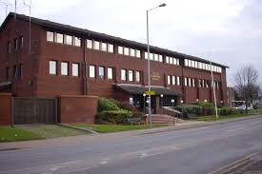
FINANCIAL PERFORMANCE (CONTINUED) Examples of major schemes and spends are set out below:

CAPITAL

The Group has a five-year capital programme to 2030/31 of around £107m. This investment will deliver a range of capital assets, including:

- New and improved fit for purpose buildings and facilities.

- Efficient vehicles appropriate to policing needs.
£3.7m investment in new vehicles

- Improved equipment and technology infrastructure.

The approved capital programme was £17.89m for 2025/26. The final capital outturn amounts to £15.11m for 2025/26.

The 2025/26 capital expenditure is split as follows:

- £1.2m was spent on improving existing buildings.
- £3.7m was spent on new vehicles purchased in accordance with the vehicle replacement programme.
- £10.2m was spent on information, communications and operational equipment, including joint projects with Humberside Police.

The above does not include IFRS 16 adjustments.
£10.2m spent on communications and operational equipment


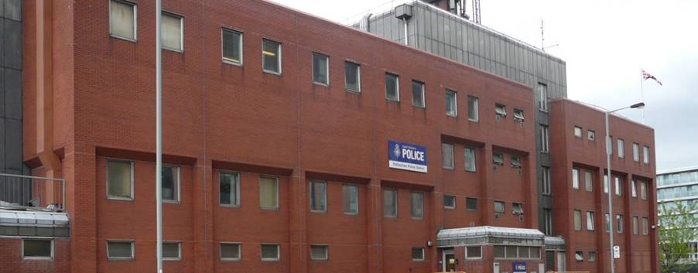
£0.29m on Ecclesfield Police Station

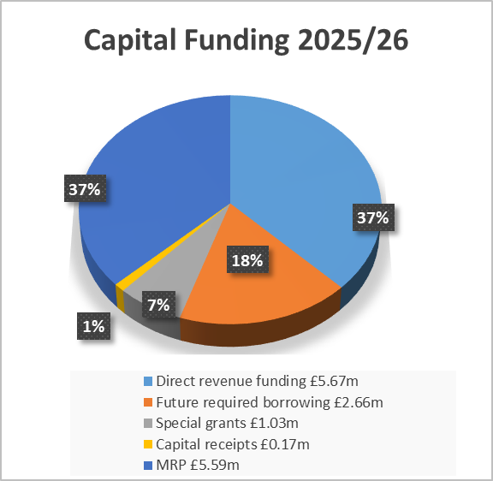

£0.31m on Rotherham Police Station



Chief Finance Officer Narrative Report (continued)

WHO WORKS FOR SOUTH YORKSHIRE POLICE?

The staffing information for the Force as at 31 March 2026 is as follows:

 | Full Time Equivalent (FTE) | Number of employees
Police Officers | 3,020.60 | 3,054
Police Community Support Officers | 110.06 | 116
Police Staff | 2,131.12 | 2,363
Total | 5,261.78 | 5,533

South Yorkshire Police employs approximately 5,500 staff in full-time and part-time positions.

In addition, the Force is supported by 71 Special Constables, 41 Police Cadets, 54 other volunteers and 15 Community Assessors.

PARTNERSHIP WORKING / COLLABORATION

The SYMCA and CC recognise that in many cases the most effective and efficient way of meeting challenges and delivering against our strategies is by working in partnership with others. The SYMCA and Force collaborate at local, district, countywide, regional and national levels with a wide range of partners. These partners include; Local Authorities, Ambulance and NHS Trusts, Fire Services, other Police Forces and a range of other groups and organisations.

Key examples include Shared Services for IT and Legal Services with Humberside Police and Shared Services for Stores across the four Yorkshire and Humber Forces. Close working with public bodies and community groups also deeply underpins the force approach to Neighbourhood Policing.

Chief Finance Officer Narrative Report (continued)

TOP STRATEGIC RISKS FOR UPCOMING YEAR

The Chief Constable of SYP has in place a high-level strategic approach designed for the handling of the Force’s Risk Management and Internal Control Systems. Risk Management supports the Chief Constable’s delivery of the Plan on a Page and therefore the Mayor’s police and Crime priorities. The CC’s Senior Command Team actively manages strategic risks and discusses these at its weekly meetings, updating the CC’s risk register as required and reporting activity to the Joint Independent Audit Committee.

Each strategic risk has: a clear description, an owner, a manager, a completion date and quantification of the risk both before and after taking account of controls and identified risk mitigations. The strategic risks as at 31 March 2026 were:

Risk | Impact | Mitigation
Legacy Matters (rewritten February 2026)  Incorporating: Hillsborough Disaster, CSE Litigation, Orgreave Public Inquiry, Grooming Gang Public Inquiry.  For all the above, the risk relates to the inability to secure funding and loss of confidence in SYP. | Loss of public/partner confidence in SYP.  Loss of public/partner confidence in SYMCA.  Ability of SYP to appropriately administer claims process in the eyes of the public.  Potential for legal challenge in relation to applications for financial assistance to the SYMCA.  No/limited Insurance Cover.  Impact of failing to provide appropriate support to previous employees (who are also SY community). | Hillsborough Disaster, CSE Litigation, Orgreave Public Inquiry continue to progress. Plans are in motion in relation to the Grooming Gangs Public Inquiry in terms of document retention.  This is a continual action whereby the Chief Constable/SYMCA/Home Office are updated on a regular basis and of key decisions.  Professional Standards continue to co-ordinate, manage and task the force to cooperate with investigations, as appropriate.  Civil claims currently ongoing – engaging in Alternative Dispute Resolution.
Risk Surrounding the Shortage of Detectives and Investigators Within Crime Services and Across the Force (raised February 2020) | It is nationally recognised that there is a shortage of detectives in the majority of Police forces nationwide and that this is resulting in a significant skills gap for forces. The position for SYP is particularly prevalent when looking at the DC cohort and PIP 2 IO roles. | The Force continues with recruitment activity launching with Detective DHEP students joining and a DCEP programme in May 2026. Participation in the TI programme is at its highest level to date with progress monitored regularly by the Learning team.
Loss of Sprotbrough Range Complex (raised Feb 2024) | The cost of losing the range each year is estimated as £382,000, excluding travel costs, fuel, and vehicle use.  Any interim measure could mean evening travel to an external cost, which will bring travel costs, potential overnight working for staff, fleet impact, quality of training plus potential pass rates, staff wellbeing, additional demand on the Firearms Training Team to manage training, cost of contract with another Force, and the reliance on other Forces, brings added risk. | There is governance in place at the OSU to monitor progress. This action is monitored through the Firearms Steering Group and also the Strategic Range Meetings.  The Force also has a tactical working group.
Chief Finance Officer Narrative Report (continued)

Concern | Impact | Mitigation
Subject Access Request Compliance (raised May 2024) | ICO enforcement/actions/fines.  Financial and reputational harm. | Current ongoing actions involve use of the ICO Data Use and Access Act (DUAA) Guidance. This aligns closely with existing practice, particularly around conducting reasonable and proportionate searches in the absence of prior formal guidance.  Work continues to return SAR open-case durations to under 6 months  Use of an Auto-Redaction Tool.  Multi-Skilling Across FOI and SAR.  Review of the Data Office structure, contributing to the assessment of future resource requirements and workflow design.
Impact and Increased Demand on the Force surrounding Dangerous Dogs (Raised March 2025) | Arisen due to change in legislation and societal changes seeing an increase in the purchase/breeding of certain dog breeds both banned breeds and non-banned breeds.  Impact on resourcing, demand and costs. | Ongoing work to review processes to ensure that dogs are seized only when necessary and that they spend the minimum amount of time necessary in Kennels.  The tenure for kennelling will commence in 2026 and a review of the amount of kennels retained for our use will be made.  Partnership work is continuing with local authorities as well as health and child safeguarding partnerships to ensure that risks are identified by relevant agencies.  Ongoing performance support and overview is being provided in the form of a dangerous dogs dashboard.
Risk Surrounding the Review Retain Dispose Process for Comms Data (raised March 2025) | It has been identified that there are concerns around Personal Data acquired via the lawful use of covert capabilities and Comms Data (CD) applications, which is currently stored within individual staff member Drives and/or shared locations within the Force or Shared Network Drives.  This storage methodology is currently unregulated and there is an absence of 'Force Policy' or a 'Standard Operating Procedure'. | Information compliance, continue to hold regular meetings to ensure that the project is progressing. Organisational Development have been approached to produce training material for investigators. This request is currently delayed by the Commissioning Board who have asked additional questions.

National risks to note that the Force is reviewing each quarter include the ongoing and ever-evolving nature of cyber threat, the risk around availability of financial resources in future years and the governance reform white paper.

For details in relation to the SYMCA risks, please review the Group Statement of Accounts.

Chief Finance Officer Narrative Report (continued)

EXPLANATION OF ACCOUNTING STATEMENTS

The financial statements have been prepared in accordance with the CIPFA Code of Practice on Local Authority Accounting. This follows International Financial Reporting Standards (IFRS) to the extent that they are meaningful and appropriate to local authority accounts as determined by His Majesty’s Treasury.

The Statements reflect the current legislative framework, central to which is the Police Reform and Social Responsibility Act 2011.

Fundamentally, the SYMCA is responsible for the finances of the whole Group and controls the assets, the majority of liabilities and the reserves. The SYMCA receives all the income and funding and makes all payments from the SYMCA Police Fund. In turn, the Chief Constable has a duty to fulfil prescribed functions under the Police Reform and Social Responsibility Act 2011 within the annual budget set by the SYMCA in consultation with the Chief Constable.

A Glossary of key terms can be found at the end of this publication.

The Core Statements are:

- Comprehensive Income and Expenditure Statement: this shows the cost for the year of providing services. The SYMCA receives all income which is, therefore, excluded from the Chief Constable’s Statement.

- Movement in Reserves Statement: this shows the movement of reserves during the year, analysed between usable and unusable reserves. The Chief Constable has no usable reserves. Unusable reserves are those that have been created to reconcile the accounting entries required to comply with the Code with those that must be statutorily charged to the General Fund Balance for council tax setting purposes. These cannot be used to support local expenditure.

- Balance Sheet: this sets out the assets, liabilities and reserves of the Chief Constable as at 31 March each year.

- Cash Flow Statement: this summarises the movements in cash and cash equivalents during the year. As all the changes in cash and cash equivalents are presented in the SYMCA’s accounts, this statement simply shows the net surplus or deficit on the provision of services adjusted for non-cash movements and for financing activities.

The Supplementary Financial Statements are:

- Statement of Accounting Policies: this sets out details of the accounting policies adopted in compiling the Statement of Accounts.

- Police Pension Fund Account: this sets out the position for the three Police Pension Scheme (1987, 2006 and 2015) Fund Accounts as at 31 March each year.

- Annual Governance Statement: this sets out the governance structures of the organisation and its key internal controls.

The Notes to these financial statements provide more detail about accounting policies and individual transactions.

Independent Auditor’s Report

Page left intentionally blank

Independent Auditor’s Report (continued)

Page left intentionally blank

Independent Auditor’s Report (continued)

Page left intentionally blank

Independent Auditor’s Report (continued)

Page left intentionally blank

Statement of Responsibilities for the Statement of Accounts

THE CHIEF CONSTABLE’S RESPONSIBILITIES

The Chief Constable is required to:

- make arrangements for the proper administration of her financial affairs and to secure that one of her officers has the responsibility for the administration of those affairs, in line with statute this is the Section 151 Officer;

- manage her affairs to secure economic, efficient and effective use of resources and safeguard her assets; and

- approve the Statement of Accounts.

THE CHIEF FINANCE OFFICER’S RESPONSIBILITIES

The Chief Finance Officer is responsible for the preparation of the Chief Constable’s Statement of Accounts in accordance with proper practices as set out in the CIPFA/LASAAC Code of Practice on Local Authority Accounting in the United Kingdom (the Code).

In preparing these Statements of Accounts, the Chief Finance Officer has:

- selected suitable accounting policies and then applied them consistently;
- made judgments and estimates that were reasonable and prudent; and
- complied with the Local Authority Code 2025/26.

The Chief Finance Officer has also:

- kept proper, up to date accounting records;
- taken reasonable steps for the prevention and detection of fraud and other irregularities;
- assessed the ability to continue as a going concern, disclosing, as applicable, matters related to going concern;
- used the going concern basis of accounting on the assumption that the functions will continue in operational existence for the foreseeable future; and
- maintained such internal control which is necessary to enable the preparation of financial statements that are free from material misstatement, whether due to fraud or error.

APPROVAL OF STATEMENT

OF ACCOUNTS

The Statement of Accounts was approved by the Chief Constable for South Yorkshire.

Lauren Poultney
Chief Constable for South Yorkshire Police

23 June 2026
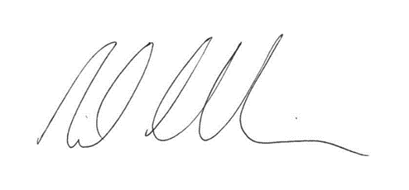Neil Chamberlain FCPFA
Chief Finance Officer, Section 151 Officer

23 June 2026

AND


Sheffield Lyceum & Crucible Theatres
3. Core Financial Statements


Comprehensive Income and Expenditure Statement
The Comprehensive Income and Expenditure Statement (CIES) shows the cost in the year of providing services in accordance with generally accepted accounting practices. All income relating to the Force is included in the SYMCA’s Income and Expenditure Statement.

2024/25 from 7 May |  |  |  |  | 2025/26
Gross | Gross | Net |  |  | Gross | Gross | Net
Expenditure | Income | Expenditure |  |  | Expenditure | Income | Expenditure
£’000 | £’000 | £’000 |  |  | £’000 | £’000 | £’000
1,805 | - | 1,805 | Senior Command Team |  | 2,520 | - | 2,520
8,520 | - | 8,520 | Deputy Chief Constable | Note 6 | 15,061 | - | 15,061
126,033 | - | 126,033 | Assistant Chief Constable (Local Policing) | Note 6 | 147,770 | - | 147,770
53,579 | - | 53,579 | Assistant Chief Constable (Crime) | Note 6 | 61,844 | - | 61,844
41,309 | - | 41,309 | Assistant Chief Constable (Operational Support, Custody & CJU) | Note 6 | 46,964 | - | 46,964
75,638 | - | 75,638 | Assistant Chief Officer (Resources) | Note 6 | 87,178 | - | 87,178
35,847 | - | 35,847 | Hillsborough Inquests / Claims |  | 5,594 | - | 5,594
6,363 | - | 6,363 | CSE / Operation Stovewood |  | 4,654 | - | 4,654
349,094 | - | 349,094 | Total Financial Resources Consumed |  | 371,585 | - | 371,585
(422,004) | - | (422,004) | Intra Group Adjustment – funding provided by the SYMCA for financial resources consumed by the Chief Constable |  | (468,446) | - | (468,446)
(72,910) | - | (72,910) | Net Cost of Policing Services |  | (96,861) | - | (96,861)
110,508 | - | 110,508 | Financing and investment income and expenditure | Note 7 | 122,463 | - | 122,463
37,598 | - | 37,598 | (Surplus) or deficit on Provision of Service |  | 25,602 | - | 25,602
 |  | (171,080) | Remeasurements of the net defined benefit liability | Note 18 |  |  | (60,519)
 |  | (171,080) | Other Comprehensive (Income) and Expenditure |  |  |  | (60,519)
 |  | (133,482) | Total Comprehensive (Income) and Expenditure |  |  |  | (34,917)

Movement in Reserves Statement

The Movement in Reserves Statement shows the movement in year of the different reserves held by the Chief Constable. The majority of the reserves are owned and managed by the SYMCA with the exception of the Pension Reserve and Accumulated Absence Reserve, which are included in the Chief Constable’s statement below.

 |  | General | Pension | Accumulated | Total | Total
 |  | Fund | Reserve | Absence | Unusable | Reserves
 |  | Balance |  | Reserve | Reserves
 |  | £’000 | £’000 | £’000 | £’000 | £’000
Balance at 7 May 2024 |  | - | (2,490,593) | (3,416) | (2,494,009) | (2,494,009)
Movement in Reserves during 2024/25
Total Comprehensive Income and Expenditure |  | (37,598) | 171,080 | - | 171,080 | 133,482
Adjustments between accounting basis and funding basis under regulations | Note 13 | 37,598 | (37,443) | (155) | (37,598) | -
Net Increase/(Decrease) before Transfers to Earmarked Reserves |  | - | 133,637 | (155) | 133,482 | 133,482
Transfers to/(from) Earmarked Reserves |  | - |  | -
Increase/(Decrease) in 2024/25 |  | - | 133,637 | (155) | 133,482 | 133,482
Balance at 31 March 2025 carried forward |  | - | (2,356,956) | (3,571) | (2,360,527) | (2,360,527)
Movement in Reserves during 2025/26
Total Comprehensive Income and Expenditure |  | (25,602) | 60,519 | - | 60,519 | 34,917
Adjustments between accounting basis and funding basis under regulations | Note 13 | 25,602 | (25,883) | 281 | (25,602) | -
Net Increase/(Decrease) before Transfers to Earmarked Reserves |  | - | 34,636 | 281 | 34,917 | 34,917
Transfers to/(from) Earmarked Reserves |  | - |  | -
Increase/(Decrease) in 2025/26 |  | - | 34,636 | 281 | 34,917 | 34,917
Balance at 31 March 2026 |  | - | (2,322,320) | (3,290) | (2,325,610) | (2,325,610)

Balance Sheet

The Balance Sheet shows the assets, liabilities and reserves as at the year end.

The net assets/ (liabilities) (assets less liabilities) are matched by the reserves held. Reserves are reported in two categories.

The first category of reserves is usable reserves, which may be used to fund services and are all held by the SYMCA.

Unusable reserves cannot be used to provide services and are used to reflect the accounting arrangements for retirement and employee benefits.

31 March 2025 |  |  | 31 March 2026
£’000 |  |  | £’000
- | Asset related to LGPS Pension Scheme | Note 18 | -
- | Long-Term Assets |  | -
- | Current Assets |  | -
- | Current Assets |  | -
(3,571) | Current Liabilities | Note 15 | (3,290)
(3,571) | Current Liabilities |  | (3,290)
(2,356,956) | Other Long-Term Liabilities | Note 16 | (2,322,320)
(2,356,956) | Long-Term Liabilities |  | (2,322,320)
(2,360,527) | Net Assets/(Liabilities) |  | (2,325,610)
- | Usable Reserves |  | -
(2,360,527) | Unusable Reserves | Note 17 | (2,325,610)
(2,360,527) | Total Reserves |  | (2,325,610)

Cash Flow Statement

The Cash Flow Statement shows the changes in cash and cash equivalents during the reporting period.

The Chief Constable has only non-cash and interest transactions as all other receipts and payments go through the Police Fund held by the SYMCA.

31 March  2025 |  |  | 31 March  2026
£’000 |  |  |  | £’000
(37,598) | Net surplus/(deficit) on the provision of services |  |  | (25,602)
37,598 | Adjustments to net (surplus)/deficit on the provision of services for non-cash movements |  | Note 19 | 25,602
150 | Adjustments for items included in the net (surplus)/deficit on the provision of services that are investing and financing activities |  | Note 19 | 154
150 | Adjusted net cash flows from Operating Activities |  |  | 154
- | Investing Activities |  |  | -
(150) | Financing Activities |  | Note 20 | (154)
- | Net Increase or decrease in cash and cash equivalents |  |  | -
- | Cash and cash equivalents at the beginning of the period |  |  | -
- | Cash and cash equivalents at the end of the reporting period |  |  | -

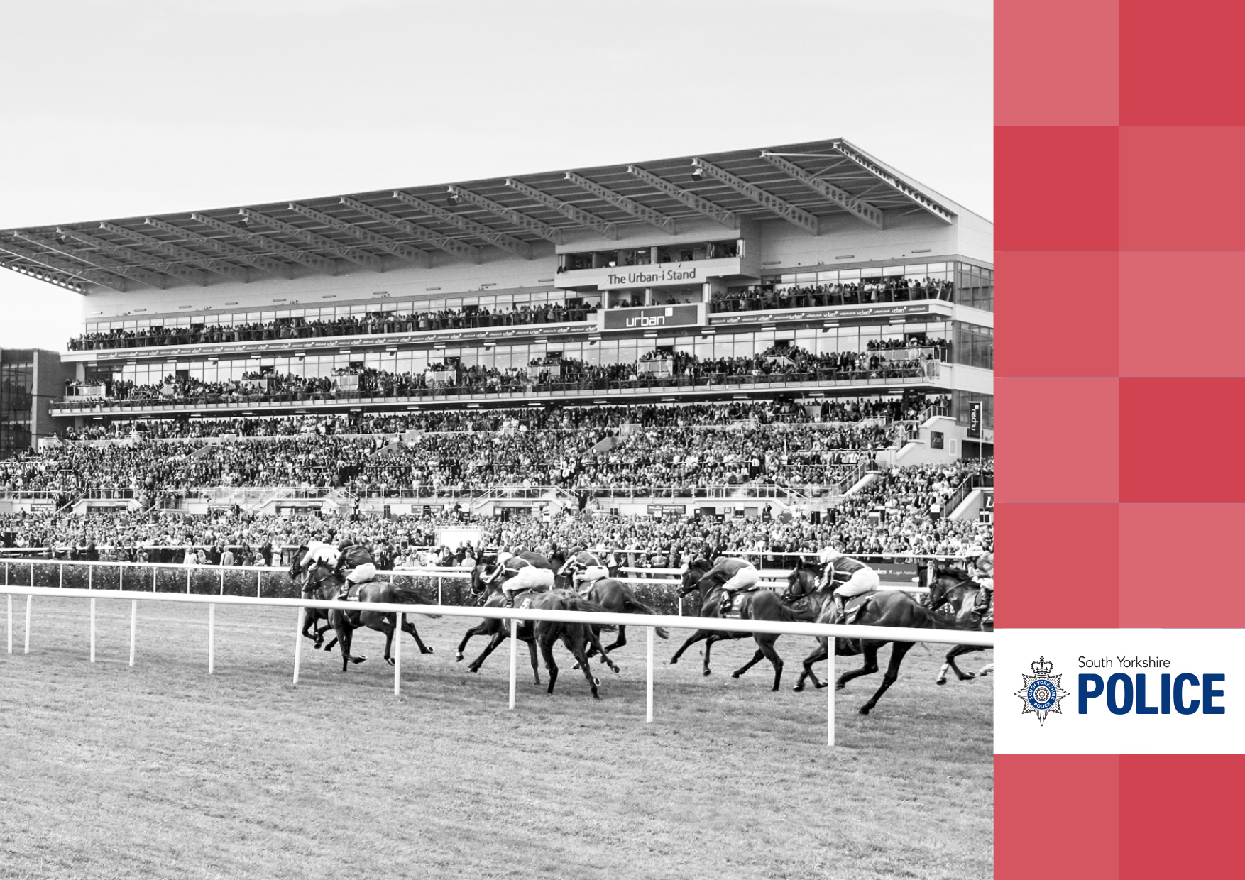
4. Notes to the Accounts
Doncaster Races

Note 1 Accounting Policies

GENERAL PRINCIPLES

The Statement of Accounts summarises the transactions of the CC for the 2025/26 financial year and its position at the year-end of 31 March 2026. The CC is required to prepare an annual Statement of Accounts by the Accounts and Audit (England) Regulations 2015. These practices primarily comprise the Code of Practice on Local Authority Accounting in the United Kingdom 2025/26, supported by International Financial Reporting Standards (IFRS).

The accounting convention adopted in the Statement of Accounts is principally historical cost, modified by the revaluation of certain categories of non-current assets and financial instruments. The Statement of Accounts have been prepared on a ‘going concern’ basis.

Further accounting policies can be found throughout these accounts with the notes to which they relate.

SYMCA AND CC RELATIONSHIP

The SYMCA and the Chief Constable are both required to prepare their own statutory accounts. The South Yorkshire Group position, which reflects the consolidated position of both the SYMCA and the Chief Constable, is included within the SYMCA’s Statement of Accounts.

The SYMCA is the holder of the Police Fund and all payments for the Group are made by the SYMCA from the Fund. The SYMCA is also the recipient of all funding, including government grant, precepts and other income that is paid into the Fund. The Comprehensive Income and Expenditure Statement for the SYMCA therefore includes all income received.

The Comprehensive Income and Expenditure Statement for the Chief Constable includes all the costs of operational policing. An intra-group adjustment is included in both the SYMCA’s and Chief Constable’s Comprehensive Income and Expenditure Statement to reflect the funding provided by the SYMCA for financial resources consumed by the Chief Constable.

All assets, liabilities and reserves are held by the SYMCA and are therefore included within the SYMCA’s Balance Sheet except for those relating to pensions and accrued employee benefits, which form part of the Chief Constable’s Balance Sheet. Since the SYMCA has control over non-current assets, and therefore retains the long-term risks and rewards of ownership, the charges to revenue for their use is included in the SYMCA’s Comprehensive Income and Expenditure Statement, analysed over the relevant service lines.

ACCRUALS OF INCOME AND EXPENDITURE

Activity is accounted for in the year that it takes place, not simply when cash payments are made or received. In particular:

- Supplies of services are recorded as expenditure when they are consumed. Where there is a gap between the date supplies are received and their consumption, they are carried as inventories in the Balance Sheet.

- Income is credited to the Comprehensive Income and Expenditure Statement in the year in which it is earned.

- Fees, charges and rents due for services provided are accounted for as income at the date that the relevant goods or services are provided.

- Interest payable on borrowings and receivable on investments is accounted for as expenditure or income respectively on the basis of the effective interest rate for the relevant financial instrument rather than the cash flows fixed or determined by the contract.

- Where income and expenditure has been recognised but cash has not yet been received or paid, a debtor or creditor for the relevant amount is recorded in the Balance Sheet. Where it is doubtful that debts will be settled, the balance of debtors is reduced and a charge made to revenue for the income that might not be collected.

- Accruals are recognised where the value exceeds £5,000.

Note 1 Accounting Policies (continued)

CHANGES IN ACCOUNTING POLICIES

Changes in accounting policies are only made when required by property accounting practices or when the change provides more reliable or relevant information about the effect of transactions, other events and conditions on the SYMCA’s financial position or financial performance. Where a change is made, it is applied retrospectively (unless stated otherwise) by adjusting opening balances and comparative amounts for the prior period as if the new policy had always been applied.

EMPLOYEE BENEFITS
Transactions relating to employee benefits are included in the financial statements of either the SYMCA or the Chief Constable according to where the direction and control of those employees lies. Short-term employee benefits are those due to be settled within 12 months of the year-end. They include salaries, paid annual leave, flexitime and other non-monetary benefits such as cars. They are recognised as an expense in the year in which employees render service.
ESTIMATES AND ERRORS

Changes in accounting estimates are accounted for prospectively, that is in the current and future years affected by the change and do not give rise to a prior period adjustment.

EXCEPTIONAL ITEMS

When items of income and expenditure are material, their nature and amount is disclosed separately, either in the Comprehensive Income and Expenditure Statement or in the Notes to the Accounts, depending on how significant the items are to an understanding of SYMCA’s performance.

FOREIGN CURRENCY TRANSLATION

Where the SYMCA has entered into a transaction using a foreign currency, the transaction is converted into sterling at the exchange rate applicable on the date the transaction was made.

PRIOR PERIOD ADJUSTMENTS

Prior period adjustments may arise as a result of a change in accounting policies or to correct a material error. Material errors discovered in prior period figures are corrected retrospectively by amending opening balances and comparative amounts for the prior period.

RESERVES

The SYMCA sets aside amounts for specific future policy purposes or to cover contingencies. Reserves are created by appropriating amounts out of the General Fund Balance in the Movement in Reserves Statement.

When expenditure to be financed from a reserve is incurred, it is charged to the appropriate service in that year against the Surplus or Deficit on the Provision of Services in the Comprehensive Income and Expenditure Statement.

The reserve is then appropriated back into the General Fund Balance in the Movement in Reserves Statement so that there is no net charge against council tax for the expenditure.

Certain other reserves are kept to manage the accounting processes for non-current assets, financial instruments, retirement and employee benefits and they do not represent usable resources for the SYMCA.

VALUE ADDED TAX

Income and expenditure excludes amounts related to VAT, as all VAT collected is payable to the His Majesty’s Revenue and Customs and all VAT is recoverable from them. During 2024/25, the Force continued to submit their own VAT return. From April 2025, SYMCA and Force transactions were submitted on a single VAT return covering all of the transactions for the Group. SYMCA is responsible for this from April 2025.

Note 2 Accounting standards issued but not yet adopted

At the balance sheet date the following new standards and amendments to existing standards have been published but not yet adopted by the Code of Practice of Local Authority Accounting in the United Kingdom:

- Amendments to FRS 102 The Financial Reporting Standard applicable in the UK and Republic of Ireland (Amendments to Heritage assets) issued in March 2024

- Amendments to the Classification and Measurement of Financial Instruments (Amendments to IFRS 9 and IFRS 7) issued in May 2024

- Annual improvements to IFRS accounting standards – Volume 11 issued in July 2024

- Contracts Referencing Nature-dependent Electricity (Amendments to IFRS 9 and IFRS 7) issued in December 2024.

Note 3 Assumptions made about the future and other
major sources of estimation uncertainty

Item | Uncertainties | Effect if Actual Results Differ from Assumptions
Pensions Liability | Estimation of the net liability to pay pensions is extremely volatile as it depends on a number of complex judgements relating to the discount rate used, the rate at which salaries are projected to increase, changes in retirement ages and mortality rates.  Actuaries are engaged to provide the CC with expert advice about the assumptions to be applied for each of its pension schemes. | Whilst the effects on the net pensions liability of changes in individual assumptions can be measured, the assumptions interact in complex ways.  During 2025/26, the Actuaries advised that the net pensions liability has decreased by approximately £60.5m as a result of estimates being revised and updating financial and demographic assumptions, along with the requirement under IFRIC 14 for the asset restriction and to recognise a minimum funding requirement in respect of the secondary contribution rate where applicable. This is reported on the Chief Constable’s Income and Expenditure Statement and further information is provided in the pensions note 18.
Pension Assets and Liability Values – LGPS | The roll-forward process used by actuaries to allocate assets and liabilities is a less accurate calculation method than the full asset and liability allocation exercise performed at each triennial actuarial valuation. | There is uncertainty in using the approximate roll forward method due to the limited data available to the actuary in inter – valuation years. If there were significant changes in data this would therefore lead to larger experience items being recorded. This would then be picked up following the next triennial valuation.
The Statement of Accounts contains estimated figures that are based on assumptions made about the future. Estimates are made taking into account historical experience, current trends and other relevant factors. However, because figures cannot be determined with certainty, actual results could be materially different from the assumptions and estimates.

The items in the Chief Constable’s Balance Sheet as at 31 March 2026 for which there is a significant risk of material adjustment in forthcoming years are as follows:

Note 3 Assumptions made about the future and other major sources of estimation uncertainty (continued)

Item | Uncertainties | Effect if Actual Results Differ from Assumptions
Pension Assets - LGPS | Accounting Standards restrict (by way of an ‘asset ceiling’) the amount of accounting surplus that the Employer may be able to disclose at its accounting year end. This refers to the cycle for setting contributions and exposure to market condition changes year-on-year that can lead to different conclusions on the asset ceiling from one set of accounts to the next. | This has resulted in LGPS surplus of £163.2m being capped at £nil.
Legacy | There is a high degree of uncertainty about the future levels of funding for the SYMCA and the impact of future legacy costs such as civil claims in relation to the Hillsborough Inquests / Claims and CSE, work being undertaken in conjunction with the National Crime Agency to investigate historic allegations of CSE (Operation Stovewood) and the events that took place at Orgreave. If the funding levels reduce and/or withdraw, this would impact the amount required to be self-funded and ultimately impact on reserves. | Impact on amount to self-fund if funding levels reduce and would impact on reserves.

Note 4 Critical judgements in applying accounting policies

In applying the accounting policies laid out in Note 1, the SYMCA and CC are required to make certain judgements about transactions or those involving uncertainty about future events. The critical judgements made in the Statement of Accounts are as follows:

- The Statement of Accounts are prepared on a going concern basis. The accounting convention adopted in the Statement of Accounts is principally historical cost, modified by the revaluation of certain categories of non-current assets and financial instruments. The concept is that the SYMCA and Chief Constable will remain in operational existence for the foreseeable future, in particular that the revenue accounts and Balance Sheet assume no intention to curtail significantly the scale of operations. The Force is reliant on the connected relationship between the SYMCA and the Force. It assumes that the SYMCA will continue to discharge its liabilities in the normal course of its business.

- A judgement has been made of the expenditure allocated between the SYMCA and the Chief Constable to reflect the financial resources of both bodies. Liabilities relating to salaries and pensions of the police officers and staff are judged to be the responsibility of the Chief Constable and are recognised in the Balance Sheet of the Chief Constable.

- The valuation from the actuary for the LGPS pension scheme calculated an asset of £163.2m. This has been adjusted under IFRIC 14 to the asset restriction, which leads to no recognition of the surplus. Further background and disclosures in relation to this approach are included in Note 18.

Note 5 Material items of Income and Expense

The Comprehensive Income and Expenditure Statement includes costs incurred of £4.654m during 2025/26 relating to CSE. Special grant funding has been received of £3.066m, which is included in the Group Comprehensive Income and Expenditure Statement.

In addition, costs of £5.594m relating to Hillsborough were incurred during 2025/26. Special grant funding has been received of £3.677m, which is included in the Group Comprehensive Income and Expenditure Statement.

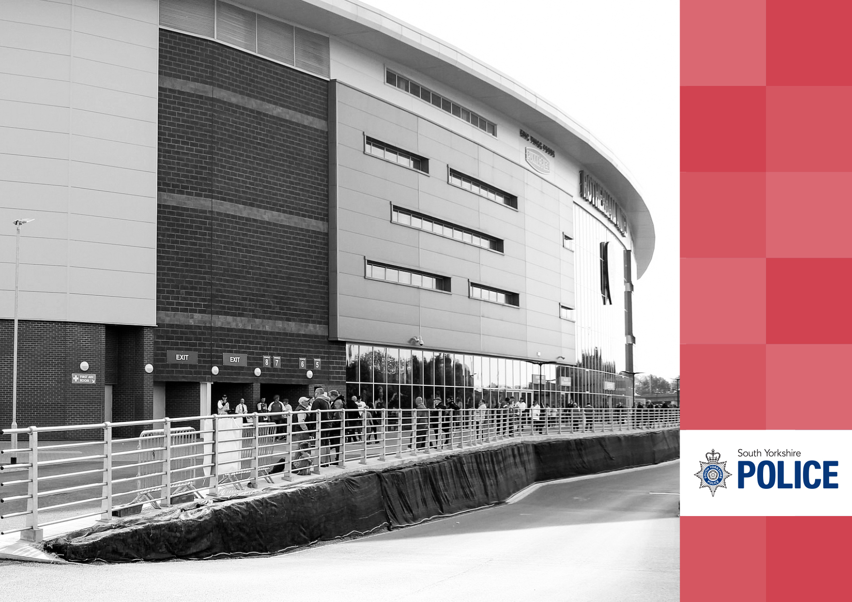
New York Stadium, Rotherham United F.C.
4.1. Notes supporting the Comprehensive Income and Expenditure Statement

Note 6 Additional Segmental Analysis

Deputy Chief Constable

2024/25 from 7 May |  |  |  | 2025/26
Gross Expenditure | Gross Income | Net Expenditure |  | Gross Expenditure | Gross Income | Net Expenditure
£’000 | £’000 | £’000 |  | £’000 | £’000 | £’000
3,097 | - | 3,097 | Professional Standards | 3,590 | - | 3,590
889 | - | 889 | Corporate Communications | 1,039 | - | 1,039
4,199 | - | 4,199 | Performance & Governance | 4,540 | - | 4,540
335 | - | 335 | Legal Services | 5,892 | - | 5,892
8,520 | - | 8,520 | Deputy Chief Constable Total | 15,061 | - | 15,061

2024/25 from 7 May |  |  |  | 2025/26
Gross Expenditure | Gross Income | Net Expenditure |  | Gross Expenditure | Gross Income | Net Expenditure
£’000 | £’000 | £’000 |  | £’000 | £’000 | £’000
17,928 | - | 17,928 | Barnsley | 20,972 | - | 20,972
27,534 | - | 27,534 | Doncaster | 32,483 | - | 32,483
20,516 | - | 20,516 | Rotherham | 22,996 | - | 22,996
41,143 | - | 41,143 | Sheffield (including Community Safety) | 48,719 | - | 48,719
18,912 | - | 18,912 | Force Control Room | 22,600 | - | 22,600
126,033 | - | 126,033 | Assistant Chief Constable (Local Policing) Total | 147,770 | - | 147,770
Assistant Chief Constable (Local Policing)

2024/25 from 7 May |  |  |  | 2025/26
Gross Expenditure | Gross Income | Net Expenditure |  | Gross Expenditure | Gross Income | Net Expenditure
£’000 | £’000 | £’000 |  | £’000 | £’000 | £’000
35,439 | - | 35,439 | Crime Services | 40,763 | - | 40,763
18,140 | - | 18,140 | Regional & Collaboration (Non Lead) | 21,081 | - | 21,081
53,579 | - | 53,579 | Assistant Chief Constable (Crime) Total | 61,844 | - | 61,844
Assistant Chief Constable (Crime)
Note 6 Additional Segmental Analysis (continued)

Assistant Chief Constable (Operational Support, Custody & CJU)
2024/25 from 7 May |  |  |  | 2025/26
Gross Expenditure | Gross Income | Net Expenditure |  | Gross Expenditure | Gross Income | Net Expenditure
£’000 | £’000 | £’000 |  | £’000 | £’000 | £’000
25,885 | - | 25,885 | Operational Support Unit | 29,566 | - | 29,566
4,546 | - | 4,546 | Criminal Justice Administration & CJU | 5,000 | - | 5,000
10,878 | - | 10,878 | Custody | 12,398 | - | 12,398
41,309 | - | 41,309 | Assistant Chief Constable (Ops Support, Custody & CJU) Total | 46,964 | - | 46,964

Assistant Chief Officer (Resources)

2024/25 from 7 May |  |  |  | 2025/26
Gross Expenditure | Gross Income | Net Expenditure |  | Gross Expenditure | Gross Income | Net Expenditure
£’000 | £’000 | £’000 |  | £’000 | £’000 | £’000
6,808 | - | 6,808 | Corporate Finance | 6,623 | - | 6,623
13,928 | - | 13,928 | Facilities Management | 16,055 | - | 16,055
4,842 | - | 4,842 | Vehicle Fleet Management | 4,962 | - | 4,962
21,997 | - | 21,997 | People and Organisational Development | 19,722 | - | 19,722
3,523 | - | 3,523 | Business Change & Innovation | 3,282 | - | 3,282
764 | - | 764 | Regional & Collaboration (Lead) | 570 | - | 570
14,226 | - | 14,226 | Information Technology | 17,383 | - | 17,383
1,528 |  | 1,528 | Digital, Data & Technology | 1,572 | - | 1,572
549 | - | 549 | Procurement | 793 | - | 793
1,598 | - | 1,598 | Non Devolved | 6,420 | - | 6,420
491 | - | 491 | Secondments | 766 | - | 766
5,384 | - | 5,384 | Grants | 9,030 | - | 9,030
75,638 | - | 75,638 | Assistant Chief Officer (Resources) Total | 87,178 | - | 87,178

Note 7 Financing and Investment Income and Expenditure

Financing and investment income and expenditure includes the interest element of the pension fund liability.

IFRS 9 Financial Instruments has been implemented in relation to impairment allowance for doubtful debts to recognise the expected credit loss.

2024/25  from 7 May |  | 2025/26
£’000 |  | £’000
110,323 | Pensions net interest cost | 122,279
35 | Impairment allowance for doubtful debts | 30
150 | Finance lease interest | 154
110,508 | Total | 122,463

Note 8 Expenditure and Funding Analysis

The Expenditure and Funding Analysis shows how annual expenditure is used and funded from resources (government grants and council tax) in comparison with those consumed or earned in accordance with generally accepted accounting practices. It also shows how this expenditure is allocated for decision making purposed between the districts and departments.

2024/25 from 7 May |  |  |  |  |  | 2025/26
Outturn position to management | Adjustments to arrive at Net Expenditure | Net Expenditure Chargeable to the General Fund | Adjustments between Funding and Accounting Basis | Net Expenditure in the CIES |  | Outturn position to management |  | Adjustments to arrive at Net Expenditure |  | Net Expenditure Chargeable to the General Fund |  | Adjustments between Funding and Accounting Basis |  | Net Expenditure in the CIES
£’000 | £’000 | £’000 | £’000 | £’000 |  | £’000 |  | £’000 |  | £’000 |  | £’000 |  | £’000
1,970 | (5) | 1,965 | (160) | 1,805 | Senior Command Team | 2,749 |  | 74 |  | 2,823 |  | (303) |  | 2,520
 |  |  |  |  | Deputy Chief Constable:
3,347 | 26 | 3,373 | (276) | 3,097 | Professional Standards | 4,087 |  | 1 |  | 4,088 |  | (498) |  | 3,590
903 | - | 903 | (14) | 889 | Corporate Communications | 1,079 |  | 8 |  | 1,087 |  | (48) |  | 1,039
4,347 | 13 | 4,360 | (161) | 4,199 | Performance & Governance | 4,912 |  | 29 |  | 4,941 |  | (401) |  | 4,540
214 | 130 | 344 | (9) | 335 | Legal Services | 5,811 |  | 132 |  | 5,943 |  | (51) |  | 5,892
8,811 | 169 | 8,980 | (460) | 8,520 | Deputy Chief Constable | 15,889 |  | 170 |  | 16,059 |  | (998) |  | 15,061
 |  |  |  |  | Assistant Chief Constable (Local Policing):
20,380 | 69 | 20,449 | (2,521) | 17,928 | Barnsley | 24,493 |  | 32 |  | 24,525 |  | (3,553) |  | 20,972
31,260 | 16 | 31,276 | (3,742) | 27,534 | Doncaster | 37,844 |  | 79 |  | 37,923 |  | (5,440) |  | 32,483
23,326 | 19 | 23,345 | (2,829) | 20,516 | Rotherham | 26,925 |  | (61) |  | 26,864 |  | (3,868) |  | 22,996
46,867 | 52 | 46,919 | (5,776) | 41,143 | Sheffield (including Community Safety) | 56,014 |  | 900 |  | 56,914 |  | (8,195) |  | 48,719
19,465 | - | 19,465 | (553) | 18,912 | Force Control Room | 24,434 |  | 1 |  | 24,435 |  | (1,835) |  | 22,600
141,298 | 156 | 141,454 | (15,421) | 126,033 | Assistant Chief Constable (Local Policing) | 169,710 |  | 951 |  | 170,661 |  | (22,891) |  | 147,770
 |  |  |  |  | Assistant Chief Constable (Crime):
37,100 | 981 | 38,081 | (2,642) | 35,439 | Crime Services | 43,839 |  | 1,241 |  | 45,080 |  | (4,317) |  | 40,763
14,026 | 4,715 | 18,741 | (601) | 18,140 | Regional & Collaboration (Non Lead) | 16,687 |  | 5,156 |  | 21,843 |  | (762) |  | 21,081
51,126 | 5,696 | 56,822 | (3,243) | 53,579 | Assistant Chief Constable (Crime) | 60,526 |  | 6,397 |  | 66,923 |  | (5,079) |  | 61,844
 |  |  |  |  | Assistant Chief Constable (Operational Support, CJU & Custody):
24,590 | 4,104 | 28,694 | (2,809) | 25,885 | Operational Support Unit |  | 28,630 |  | 4,684 |  | 33,314 |  | (3,748) |  | 29,566
4,100 | 462 | 4,562 | (16) | 4,546 | Criminal Justice Administration & CJU |  | 4,738 |  | 570 |  | 5,308 |  | (308) |  | 5,000
11,291 | 293 | 11,584 | (706) | 10,878 | Custody |  | 13,406 |  | 108 |  | 13,514 |  | (1,116) |  | 12,398
39,981 | 4,859 | 44,840 | (3,531) | 41,309 | Assistant Chief Constable (Operational Support, CJU & Custody) |  | 46,774 |  | 5,362 |  | 52,136 |  | (5,172) |  | 46,964

Note 8 Expenditure and Funding Analysis (continued)

2024/25 from 7 May |  |  |  |  |  | 2025/26
Outturn position to management | Adjustments to arrive at Net Expenditure | Net Expenditure Chargeable to the General Fund | Adjustments between Funding and Accounting Basis | Net Expenditure in the CIES |  | Outturn position to management | Adjustments to arrive at Net Expenditure | Net Expenditure Chargeable to the General Fund | Adjustments between Funding and Accounting Basis | Net Expenditure in the CIES
£’000 | £’000 | £’000 | £’000 | £’000 |  | £’000 | £’000 | £’000 | £’000 | £’000
 |  |  |  |  | Assistant Chief Officer (Resources):
7,653 | 795 | 8,448 | (1,640) | 6,808 | Corporate Finance | 8,386 | 434 | 8,820 | (2,197) | 6,623
12,624 | 1,480 | 14,104 | (176) | 13,928 | Facilities Management | 14,299 | 2,172 | 16,471 | (416) | 16,055
4,648 | 215 | 4,863 | (21) | 4,842 | Vehicle Fleet Management | 4,881 | 196 | 5,077 | (115) | 4,962
23,497 | 940 | 24,437 | (2,440) | 21,997 | People and Organisational Development | 25,520 | (2,677) | 22,843 | (3,121) | 19,722
3,422 | 153 | 3,575 | (52) | 3,523 | Business Change & Innovation | 3,255 | 152 | 3,407 | (125) | 3,282
364 | 407 | 771 | (7) | 764 | Regional & Collaboration (Lead) | 2 | 604 | 606 | (36) | 570
14,794 | (504) | 14,290 | (64) | 14,226 | Information Technology | 17,868 | (72) | 17,796 | (413) | 17,383
1,554 | - | 1,554 | (26) | 1,528 | Digital, Data & Technology | 1,698 | - | 1,698 | (126) | 1,572
556 | - | 556 | (7) | 549 | Procurement | 840 | - | 840 | (47) | 793
(21,009) | 22,638 | 1,629 | (31) | 1,598 | Non-Devolved | (18,527) | 25,077 | 6,550 | (130) | 6,420
95 | 467 | 562 | (71) | 491 | Secondments | 281 | 632 | 913 | (147) | 766
- | 5,384 | 5,384 | - | 5,384 | Grants | - | 10,040 | 10,040 | (1,010) | 9,030
48,198 | 31,975 | 80,173 | (4,535) | 75,638 | Assistant Chief Officer (Resources) | 58,503 | 36,558 | 95,061 | (7,883) | 87,178
1,276 | 34,573 | 35,849 | (2) | 35,847 | Hillsborough Inquests / Claims | 919 | 4,704 | 5,623 | (29) | 5,594
3,139 | 3,224 | 6,363 | - | 6,363 | CSE / Operation Stovewood | 1,591 | 3,066 | 4,657 | (3) | 4,654
295,799 | 80,647 | 376,446 | (27,352) | 349,094 | Cost of Services | 356,661 | 57,282 | 413,943 | (42,358) | 371,585
 |  | (376,446) | (45,558) | (422,004) | Intra-group adjustment – funding provided by the SYMCA for financial resources consumed by the Chief Constable |  |  | (413,943) | (54,503) | (468,446)
 |  | - | 110,508 | 110,508 | Financing and Investment |  |  | - | 122,463 | 122,463
 |  | - | 37,598 | 37,598 | (Surplus) or Deficit |  |  | - | 25,602 | 25,602
 |  | - |  |  | Opening General Fund |  |  | -
 |  | - |  |  | Less/Plus Surplus or (Deficit) on General Fund in Year |  |  | -
 |  | - |  |  | Closing General Fund at 31 March |  |  | -

Note 8 Expenditure and Funding Analysis (continued)

Adjustments from the General Fund to arrive at the Comprehensive Income and Expenditure Statement amounts:

2024/25 from 7 May |  |  |  |  |  | 2025/26
Adjustments for Capital Purposes | Net change for the Pension Adjustments | Other Differences | Total Adjustments |  |  | Adjustments for Capital Purposes | Net change for the Pension Adjustments | Other Differences | Total Adjustments
£’000 | £’000 | £’000 | £’000 |  |  | £’000 | £’000 | £’000 | £’000
- | (181) | 21 | (160) | Senior Command Team |  | - | (282) | (21) | (303)
 |  |  |  | Deputy Chief Constable:
- | (281) | 5 | (276) | Professional Standards |  | - | (495) | (3) | (498)
- | (9) | (5) | (14) | Corporate Communications |  | - | (56) | 8 | (48)
- | (171) | 10 | (161) | Performance & Governance |  | - | (386) | (15) | (401)
- | (9) | - | (9) | Legal Services |  | - | (53) | 2 | (51)
- | (470) | 10 | (460) | Deputy Chief Constable |  | - | (990) | (8) | (998)
 |  |  |  | Assistant Chief Constable (Local Policing):
- | (2,532) | 11 | (2,521) | Barnsley |  | - | (3,536) | (17) | (3,553)
- | (3,783) | 41 | (3,742) | Doncaster |  | - | (5,404) | (36) | (5,440)
- | (2,831) | 2 | (2,829) | Rotherham |  | - | (3,860) | (8) | (3,868)
- | (5,841) | 65 | (5,776) | Sheffield (including Community Safety) |  | - | (8,170) | (25) | (8,195)
- | (559) | 6 | (553) | Force Control Room |  | - | (1,743) | (92) | (1,835)
- | (15,546) | 125 | (15,421) | Assistant Chief Constable (Local Policing) |  | - | (22,713) | (178) | (22,891)
 |  |  |  | Assistant Chief Constable (Crime):
- | (2,717) | 75 | (2,642) | Crime Services |  | - | (4,291) | (26) | (4,317)
- | (601) | - | (601) | Regional & Collaboration (Non Lead) |  | - | (762) | - | (762)
- | (3,318) | 75 | (3,243) | Assistant Chief Constable (Crime) |  | - | (5,053) | (26) | (5,079)
 |  |  |  | Assistant Chief Constable (Operational Support, Custody & CJU):
- | (2,806) | (3) | (2,809) | Operational Support Unit |  | - | (3,709) | (39) | (3,748)
- | (53) | 37 | (16) | Criminal Justice Administration & CJU |  | - | (309) | 1 | (308)
- | (700) | (6) | (706) | Custody |  | - | (1,070) | (46) | (1,116)
- | (3,559) | 28 | (3,531) | Assistant Chief Constable (Operational Support, Custody & CJU) |  | - | (5,088) | (84) | (5,172)

Note 8 Expenditure and Funding Analysis (continued)

2024/25 from 7 May |  |  |  |  |  | 2025/26
Adjustments for Capital Purposes | Net change for the Pension Adjustments | Other Differences | Total Adjustments |  |  | Adjustments for Capital Purposes | Net change for the Pension Adjustments | Other Differences | Total Adjustments
£’000 | £’000 | £’000 | £’000 |  |  | £’000 | £’000 | £’000 | £’000
 |  |  |  | Assistant Chief Officer (Resources):
- | (1,600) | (40) | (1,640) | Corporate Finance |  | - | (2,166) | (31) | (2,197)
(150) | (41) | 15 | (176) | Facilities Management |  | (154) | (243) | (19) | (416)
- | (20) | (1) | (21) | Vehicle Fleet Management |  | - | (116) | 1 | (115)
- | (2,314) | (126) | (2,440) | People and Organisational Development |  | - | (3,102) | (19) | (3,121)
- | (32) | (20) | (52) | Business Change & Innovation |  | - | (121) | (4) | (125)
- | (8) | 1 | (7) | Regional & Collaboration (Lead) |  | - | (34) | (2) | (36)
- | (76) | 12 | (64) | Information Technology |  | - | (417) | 4 | (413)
- | (42) | 16 | (26) | Digital, Data & Technology |  | - | (132) | 6 | (126)
 | (7) | - | (7) | Procurement |  | - | (46) | (1) | (47)
- | (35) | 4 | (31) | Non-Devolved |  | - | (191) | 61 | (130)
- | (71) | - | (71) | Secondments |  | - | (157) | 10 | (147)
- | - | - | - | Grants |  | - | (1,010) | - | (1,010)
(150) | (4,246) | (139) | (4,535) | Assistant Chief Officer (Resources) |  | (154) | (7,735) | 6 | (7,883)
- | (2) | - | (2) | Hillsborough Inquests / Claims |  | - | (29) | - | (29)
- | - | - | - | CSE / Operation Stovewood |  | - | (3) | - | (3)
(150) | (27,322) | 120 | (27,352) | Net Cost of Services |  | (154) | (41,893) | (311) | (42,358)
- | (45,558) | - | (45,558) | Intra-group adjustment – funding provided by the SYMCA for financial resources consumed by the Chief Constable |  | - | (54,503) | - | (54,503)
150 | 110,323 | 35 | 110,508 | Other income and expenditure |  | 154 | 122,279 | 30 | 122,463
- | 37,443 | 155 | 37,598 | Difference between the General Fund surplus or deficit and the CIES surplus or deficit |  | - | 25,883 | (281) | 25,602

Note 8 Expenditure and Funding Analysis (continued)

Adjustments for Capital purposes

This column adds in depreciation and impairment and revaluation gains and losses in the service line. For other operating expenditure, it adjusts for capital disposals with a transfer of income on disposal of assets and the amounts written off for those assets. For financing and investment income and expenditure, it adjusts for the statutory charges for capital financing and investment i.e. Minimum Revenue Provision and other revenue contributions are deducted from other income and expenditure as these are not chargeable under generally accepted accounting practices. For taxation and non-specific grant income and expenditure, capital grants are adjusted for income not chargeable under generally accepted accounting practices. Revenue grants are adjusted from those receivable in the year to those receivable without conditions or for which conditions were satisfied throughout the year. The taxation and non-specific grant income and expenditure line is credited with capital grants receivable in the year without conditions or for which conditions were satisfied in the year.

Net change for the pensions adjustments

This column adjusts for the net change for the renewal of pension contributions and the addition of IAS 19 Employee Benefits pension related expenditure and income. For services, this represents the removal of the employer pension contributions made by the authority as allowed by statute and the replacement with current service costs and past service costs. For financing and investment income and expenditure, this adjusts for the net interest on the defined benefit liability is charged to the Comprehensive Income and Expenditure Statement.

Other differences

Other differences between amounts debited / credited to the Comprehensive Income and Expenditure Statement and amounts payable / receivable to be recognised under statute. For services, this represents removal of the annual leave accrual adjustment. For financing and investment income and expenditure the other differences column recognises adjustments to General Fund for the timing differences for premiums and discounts and financial instruments. The charge under taxation and non-specific grant income and expenditure represents the difference between what is chargeable under statutory regulations for Council Tax and Non-Domestic Rates that was projected to be received at the start of the year and the income recognised under generally accepted accounting practices in the Code. This is a timing difference, as any difference will be brought forward in future surpluses or deficits on the Collection Fund. The impairment allowance for doubtful debts is also included here.

Note 9 Subjective Analysis

Expenditure for the Force split by type rather than by district and department:

2024/25  from 7 May |  | 2025/26
£’000 |  | £’000
250,523 | Employee Costs | 285,991
8,651 | Premises Costs | 9,790
5,214 | Transport Costs | 6,780
59,981 | Supplies and Services Costs | 34,763
23,898 | Agency | 28,592
827 | Capital Charges & Impairment of Assets | 5,669
- | Income | -
349,094 | Cost of Services | 371,585
(422,004) | Intra-Group Adjustment | (468,446)
(72,910) | Net Cost of Policing Services | (96,861)

061 |

Note 10 Officers’ Remuneration (including Termination Benefits and Members’ Allowances)

The remuneration of senior employees, defined as those who are members of the Senior Command Team, those holding statutory posts, or those whose remuneration is £150,000 or more per year.

2024/25 | Salary, Fees and Allowances | Expenses | Benefits in Kind | Other Payments | Total Remuneration | Pension Contribution | Total
 | £ | £ | £ | £ | £ | £ | £
Chief Constable – L Poultney | 190,338 | - | - | - | 190,338 | 55,721 | 246,059
Deputy Chief Constable – S Poolman | 157,241 | - | - | - | 157,241 | 46,034 | 203,275
Assistant Chief Constable – Local Policing & Force Control Room (1) | 42,503 | - | - | - | 42,503 | 15,004 | 57,507
Assistant Chief Constable – Local Policing & Force Control Room (2) | 134,013 | - | - | - | 134,013 | 36,397 | 170,410
Assistant Chief Constable – Crime Services (3) | 93,929 | - | - | - | 93,929 | 26,068 | 119,997
Assistant Chief Constable – OSU (4) | 44,060 | - | - | - | 44,060 | - | 44,060
Assistant Chief Constable – Ops Support (5) | 74,195 | - | - | - | 74,195 | 26,191 | 100,386
Assistant Chief Constable – OSU, DDAT & IT (5) | 56,565 | - | - | - | 56,565 | 11,980 | 68,545
Assistant Chief Officer – Resources | 145,783 | - | - | - | 145,783 | 26,651 | 172,434
Chief Finance Officer (6) | 85,050 | - | - | - | 85,050 | 16,244 | 101,294
Chief Finance Officer (7) | 16,200 | - | - | - | 16,200 | - | 16,200

Notes
(1) Left the organisation on the 29 July 2024
(2) Commenced role on the 12 May 2024
(3) Commenced role on the 17 June 2024
(4) Left the organisation on the 31 August 2024, role 23 hrs per week
(5) Transitioned roles on the 1 November 2024
(6) Left the organisation on the 10 February 2025
(7) Commenced role on the 14 February 2025 - External Consultant

For this purpose the 12 month period to 31 March 2024 was used, as this provides information that is more reflective and comparative.
Note 10 Officers’ Remuneration (including Termination Benefits and Members’ Allowances) (continued)

2025/26 | Salary, Fees and Allowances | Expenses | Benefits in Kind | Other Payments | Total Remuneration | Pension Contribution | Total
 | £ | £ | £ | £ | £ | £ | £
Chief Constable – L Poultney | 204,263 | - | - | - | 204,263 | 64,591 | 268,854
Deputy Chief Constable – S Poolman | 168,548 | - | - | - | 168,548 | 53,298 | 221,846
Assistant Chief Constable – Local Policing & Force Control Room | 138,844 | - | - | - | 138,844 | 43,929 | 182,773
Assistant Chief Constable – Crime | 129,423 | - | - | - | 129,423 | 40,888 | 170,311
Assistant Chief Constable – OSU, Custody & CJU (1) | 80,295 | - | - | - | 80,295 | 23,287 | 103,582
Assistant Chief Constable – OSU, DDAT & IT (2) | 56,565 | - | - | - | 56,565 | 19,967 | 76,532
Assistant Chief Officer – Resources - J Bland | 151,955 | - | - | - | 151,955 | 30,015 | 181,970
Chief Finance Officer (3) | 131,400 | - | - | - | 131,400 | - | 131,400

Notes

(1) Commenced role on 1st September 2025
(2) Left the organisation on the 31st August 2025
(3) External Consultant

Note 10 Officers’ Remuneration (including Termination Benefits and Members’ Allowances) (continued)

2024/25 |  | 2025/26
Number | £ | Number
543 | 50,000 - 54,999 | 547
329 | 55,000 – 59,999 | 429
187 | 60,000 – 64,999 | 175
132 | 65,000 – 69,999 | 149
47 | 70,000 – 74,999 | 92
18 | 75,000 – 79,999 | 24
14 | 80,000 – 84,999 | 7
13 | 85,000 – 89,999 | 10
6 | 90,000 – 94,999 | 7
7 | 95,000 – 99,999 | 10
- | 100,000 – 104,999 | 3
2 | 105,000 – 109,999 | 4
3 | 110,000 – 114,999 | 4
- | 115,000 – 119,999 | -
- | 120,000 – 124,999 | -
- | 125,000 – 129,999 | 1
2 | 130,000 – 134,999 | -
- | 135,000 – 139,999 | 1
- | 140,000 – 144,999 | -
1 | 145,000 – 149,999 | -
- | 150,000 – 154,999 | 1
1 | 155,000 – 159,999 | -
- | 160,000 – 164,999 | -
- | 165,000 – 169,999 | 1
- | 170,000 – 174,999 | -
- | 175,000 – 179,999 | -
- | 180,000 – 184,999 | -
- | 185,000 – 189,999 | -
1 | 190,000 – 194,999 | -
- | 195,000 – 199,999 | -
- | 200,000 – 204,999 | 1
1,306 |  | 1,466
Employees (both police officers and staff), of the Chief Constable, including the senior employees identified in the previous table and termination packages, receiving more than £50,000 remuneration for the year (excluding employer’s pension contributions but including taxable expenses) were paid the following amounts:

For this purpose the 12 month period comparisons of 31 March 2025 have been used, as this provides information that is more reflective and comparative.

A number of employees work in shared services with other regional forces. Disclosure of such employees is made in the accounts of the force that holds the employment contract of those individuals.

Note 10 Officers’ Remuneration (including Termination Benefits and Members’ Allowances) (continued)

EXIT PACKAGES

The number of exit packages with total cost per band and total cost of the compulsory and other redundancies are set out in the table below:

 | 2024/25 from 7 May |  |  |  |  | 2025/26
Number of compulsory redundancies | Number of other departures agreed | Total number of exit packages by cost band | Total cost of exit packages in each band | Exit package cost band (including special payments) | Number of compulsory redundancies | Number of other departures agreed | Total number of exit packages by cost band | Total cost of exit packages in each band
 |  |  | £’000 |  |  |  |  | £’000
1 | 3 | 4 | 26 | £0 - £20,000 | 8 | 1 | 9 | 61
- | - | - | - | £20,001 - £40,000 | 1 | 1 | 2 | 52
1 | - | 1 | 66 | £40,001 - £60,000 | - | - | - | -
- | - | - | - | £60,001 - £80,000 | 1 | - | 1 | 62
- | - | - | - | £80,001 - £100,000 | 1 | - | 1 | 97
- | - | - | - | £100,001 - £120,000 | - | - | - | -
- | - | - | - | £120,001 - £140,000 | - | - | - | -
- | - | - | - | £140,001 - £160,000 | - | - | - | -
- | - | - | - | £160,001+ | - | - | - | -
2 | 3 | 5 | 92 | Total | 11 | 2 | 13 | 272

TERMINATION BENEFITS

Termination benefits are payable following a decision by the Force to terminate an officer’s employment before their normal retirement date or an officer’s decision to accept voluntary redundancy in exchange for those benefits. Costs are charged on an accruals basis to the respective service line in the Comprehensive Income and Expenditure Statement at the earlier of when the Force can no longer withdraw the offer of the benefits or when the Force recognises costs for a restructuring.

During 2025/26, there were 11 compulsory redundancies at a cost of £232,000 (2 staff £84,000 in 2024/25) and 2 staff whose contracts were terminated as other departures at a cost of £40,000 (3 staff at £8,000 in 2024/25).

MEMBERS’ ALLOWANCES

The Joint Independent Audit Committee (JIAC) members were paid allowances of £6,238 for all members in total in 2025/26 (£8,156 in 2024/25). The Independent Ethics Panel members were paid allowances of £6,167 in 2025/26 (£6,152 in 2024/25). The Independent Advisory Panel on Policing Protests (IAPPP) members were paid allowances of £0 in 2025/26 (£0 in 2024/25). The Independent Members that sit on misconduct hearings were paid allowances of £14,553 in 2025/26 (£12,972 in 2024/25). All expenditure is included in the Group accounts.

Note 11 External Audit Fees

The Chief Constable has incurred the following costs in relation to the audit of the Statement of Accounts, certification of grant claims and statutory inspections and non-audit services provided by the external auditors:

2024/25  From 7 May |  | 2025/26
£’000 |  | £’000
63 | Fees payable with regard to external audit services carried out by the appointed auditor for the year | 65
- | Fees due relating to prior years | 11
(8) | Redmond review audit fees grant | (8)
55 |  | 68

Note 12 Regional Working

The SYMCA and Chief Constable engage with other Yorkshire and Humber region PCCs and Chief Constables to deliver a number of services on a regional basis. The Regional Collaboration Programme was developed to bring opportunities across many policing activities whilst retaining local identity and accountability.

Since September 2013, a lead force model was adopted for each functional area of regional collaboration, with the Regional Collaboration Board retaining responsibility for the governance arrangements. South Yorkshire is lead force for Regional Procurement and during 2014/15 took lead force responsibility for Regional Stores. It provides all financial administration necessary to ensure that the costs are properly captured and fully recharged to the four participating PCCs and Chief Constables. Following an extensive review, a decision was made in March 2023 that Regional Procurement would be devolved to form local procurement teams from 1 July 2024. Regional Stores will continue to be a collaboration with Humberside Police and West Yorkshire Police.

The lead force arrangements have been reviewed against IFRS 11 on Joint Arrangements and it has been determined that they fall outside the scope of a joint operation.

The summary position for these services is detailed in the memorandum below.

2024/25 from 7 May |  |  | 2025/26
Stores  £’000 | Procurement  £’000 |  | Stores  £’000
458 | 308 | Staff costs | 614
158 | (1) | Premises related expenses | 197
8 | - | Transport related expenses | 10
116 | 7 | Supplies and services | 45
740 | 314 | Expenditure | 866
- | - | Other reimbursed income | -
(740) | - | Contributions (see below) | (858)
- | (314) | Previous underspends utilised | -
(740) | (314) | Income | (858)
- | - | (Under)/overspends in year | 8
- | - | Previous (under)/overspend not utilised | (131)
(131) | - | Balance c/f in current liabilities | (123)
 |  | Contributions
(154) | - | Humberside Police | (185)
- | - | North Yorkshire Police | -
(220) | - | South Yorkshire Police | (259)
(366) | - | West Yorkshire Police | (414)
(740) | - | Total | (858)

Note 12 Regional Working (continued)

The governance of the regional programme is undertaken by a Regional Collaboration Board headed by the four PCCs/Combined Authorities and attended by their Chief Executives and the Chief Constables.

The table shows the contributions made in 2025/26 by the South Yorkshire Mayor Combined Authority, to those services for which other regional forces are the lead force.

Regional Service | Lead Force Responsibility | 2025/26
 |  | Contribution
 |  | £’000
Underwater/Marine | Humberside Police | 151
Scientific Support | West Yorkshire Police | 6,608
Technical Support Unit including ROCU | West Yorkshire Police | 4,749
External Forensics | West Yorkshire Police | 2,386
Collision Investigation Unit | West Yorkshire Police | 944
Prison Intelligence Unit | West Yorkshire Police | 17
Secretarial Support | West Yorkshire Police | 4

Note 12 Regional Working (continued)

The SYMCA has collaborative working arrangements with Humberside PCC for the joint service of Information Technology (IT). The venture has a collaboration agreement under Section 22A of the Police Act 1996 covering the main responsibilities. The costs are shared based on the total size of the respective force budgets, assessed using a measure of “net revenue expenditure” (NRE).

The joint collaboration arrangement with Humberside PCC is treated as a joint operation under IFRS 11, with only South Yorkshire’s share of income and expenditure being recognised in the Group Comprehensive Income and Expenditure Statement and only its share of jointly procured fixed assets in the Balance Sheet.

The summary position for these services is detailed in the memorandum below:

2024/25  From 7 May |  |  | 2025/26
Information Technology  £’000 |  |  |  | Information Technology  £’000
6,074 |  | Staff costs |  | 7,100
- |  | Premises related expenses |  | -
78 |  | Transport related expenses |  | 87
6,335 |  | Supplies and services |  | 8,591
- |  | Third party costs |  | -
12,487 |  | Expenditure |  | 15,778
(12,487) |  | Contributions (see below) |  | (15,778)
- |  | Other income |  | -
(12,487) |  | Income |  | (15,778)
- |  | Deficit/(Surplus) in year |  | -
 |  | Contributions
(5,108) |  | Humberside Police |  | (6,547)
(7,379) |  | South Yorkshire Police |  | (9,231)
(12,487) |  | Total |  | (15,778)
40.91% |  | Humberside Police % share of costs |  | 41.49%
59.09% |  | South Yorkshire Police % share of costs |  | 58.51%


Meadowhall shopping centre
4.2. Notes supporting the Movement in Reserves Statement

Note 13 Adjustments between Accounting Basis and Funding Basis under Regulations

This note details the adjustments that are made to the total Comprehensive Income and Expenditure recognised by the Chief Constable within the year to the resources that are specified by statutory provisions as being available to the Chief Constable to meet future capital and revenue expenditure, in accordance with proper accounting practice.

2024/25 from 7 May | Usable Reserves |  |  |  | Movement in Unusable Reserves
 | General Fund Balance | Earmarked General Fund Reserves | Capital Receipts Reserve | Capital Grants Unapplied
 | £’000 | £’000 | £’000 | £’000 | £’000
Adjustments primarily involving the Pension Reserve:
Reversal of items relating to retirement benefits debited or credited to the CIES | 139,018 | - | - | - | (139,018)
Employer’s pension contributions and direct payments to pensioners payable in the year | (101,575) | - | - | - | 101,575
Adjustments primarily involving the Accumulated Absence Account:
Amount by which officer remuneration charged to the CIES on an accruals basis is different from remuneration chargeable in the year in accordance with statutory requirements | 155 | - | - | - | (155)
Total Adjustments | 37,598 | - | - | - | (37,598)

Note 13 Adjustments between Accounting Basis and Funding Basis under regulations (continued)

2025/26 | Usable Reserves |  |  |  | Movement in Unusable Reserves
 | General Fund Balance | Earmarked General Fund Reserves | Capital Receipts Reserve | Capital Grants Unapplied
 | £’000 | £’000 | £’000 | £’000 | £’000
Adjustments primarily involving the Pension Reserve:
Reversal of items relating to retirement benefits debited or credited to the CIES | 147,420 | - | - | - | (147,420)
Employer’s pension contributions and direct payments to pensioners payable in the year | (121,537) | - | - | - | 121,537
Adjustments primarily involving the Accumulated Absence Account:
Amount by which officer remuneration charged to the CIES on an accruals basis is different from remuneration chargeable in the year in accordance with statutory requirements | (281) | - | - | - | 281
Total Adjustments | 25,602 | - | - | - | (25,602)


4.3. Notes supporting the Balance Sheet
Cannon Hall

Note 14 Leases

Leases are classified as finance leases where the terms of the lease transfer substantially all the risks and rewards incidental to ownership of the property, plant or equipment from the lessor to the lessee. Where a lease covers land and buildings, the land and buildings elements are considered separately for classification. Arrangements that do not have the legal status of a lease but convey a right to use an asset in return for payment are accounted for under this policy where fulfilment of the arrangement is dependent on the use of specific assets.

Change in Accounting Policy and Transition to IFRS 16 Lease Accounting
In 2023/24 the Force voluntarily applied IRFS 16 Leases as permitted by the Code of Practice for Local Authority Accounting in the United Kingdom. The main impact of the new requirements is that for arrangements previously accounted for as operating leases (i.e. without recognising the leased property as an asset and future rents as a liability) a right-of use asset and a lease liability are brought into the balance sheet. Leases for items of low value and leases that expire on or before 31 March 2026 are exempt from the new arrangements. The impact on these changes are shown in the Group accounts.

The Force as a Lessee

Finance Leases
All Finances Leases are under the SYMCA and included in the Group accounts. This includes Right of Use assets and Peppercorn assets at fair value.

Transactions under leases
The SYMCA has leases for some properties and equipment. These are used by the Chief Constable and the Force incurred the following expenses and cash flows in relation to leases:

2024/25  From 7 May  £’000 |  | 2025/26  £’000
150 | Interest expense on lease liabilities | 154
- | Expense relating to short-term leases | 3
138 | Expense relating to exempt lease of low-value items | 126
288 | Total | 283

Maturity analysis of lease liabilities
The lease liabilities are due to be settled over the following time bands (measured at the undiscounted amounts of expected cash payments):

Non-IFRS 16 (exemptions/low value)

31 March  2025  £’000 |  | 31 March 2026  £’000
128 | Less than one year | 100
150 | More than one year and less than five years | 50
- | More than five years | -
278 | Total | 150

IFRS 16

31 March  2025  £’000 |  | 31 March 2026  £’000
379 | Less than one year | 379
1,605 | More than one year and less than five years | 1,651
1,272 | More than five years | 848
3,256 | Total | 2,878

Note 15 Creditors

31 March  2025 |  | 31 March 2026
£’000 |  | £’000
3,571 | Other entities and individuals | 3,290
3,571 | Total | 3,290

Note 16 Other Long-Term Liabilities

31 March  2025 |  | 31 March 2026
£’000 |  | £’000
2,356,956 | Pensions Liability | 2,322,320
2,356,956 | Total | 2,322,320

Note 17 Unusable Reserves

31 March  2025 |  | 31 March 2026
£’000 |  | £’000
(3,571) | Accumulated Absences Account | (3,290)
(2,356,956) | Pension Reserve | (2,322,320)
(2,360,527) | Total | (2,325,610)

119 |

THE

Note 17 Unusable Reserves (continued)

Accumulated Absences Account

An accrual is made for the cost of holiday entitlements and other forms of leave, such as time off in lieu, earned by the employee but not taken before the year-end which employees can carry forward into the next financial year. The accrual is made at the salary rates applicable in the following accounting year, being the period in which the employee takes the benefit. An accrual is charged to the Surplus or Deficit on the Provision of Services within the Comprehensive Income and Expenditure Statement and then reversed out through the Movement in Reserves Statement so that holiday benefits are charged to revenue in the financial year which the holiday absence occurs.

The Accumulated Absences Account absorbs the differences that would otherwise arise on the General Fund Balance from accruing for compensated absences earned but not taken in the year, for example annual leave entitlement carried forward as at 31 March. Statutory arrangements require that the impact on the General Fund Balance is neutralised by transfers to or from this Account.

31 March  2025 |  | 31 March  2026
£’000 |  | £’000
(3,416) | Balance at 1 April / 7 May | (3,571)
- | Settlement or cancellation of accrual made at the end of preceding year | 281
(155) | Amounts accrued at the end of the current year | -
(155) | Amount by which officer remuneration charged to the Comprehensive Income and Expenditure Statement on an accruals basis is different from remuneration chargeable in the year in accordance with statutory requirements | 281
(3,571) | Total | (3,290)

Note 17 Unusable Reserves (continued)

Pension Reserve
31 March  2025 |  | 31 March  2026
£’000 |  | £’000
(2,490,593) | Balance at 1 April / 7 May | (2,356,956)
171,080 | Actuarial gains or (losses) on the pensions assets and liabilities | 60,519
(139,018) | Reversal of items relating to retirement benefits debited or credited to the Surplus or Deficit on the Provision of Services in the Comprehensive Income and Expenditure Statement | (147,420)
101,575 | Employer’s pensions contributions and direct payments to pensioners payable in the year | 121,537
- | Past service deficit paid in advance | -
(2,356,956) | Total | (2,322,320)

The Pensions Reserve absorbs the timing differences arising from the different arrangements for accounting for post-employment benefits and for funding benefits in accordance with statutory provisions.

Post-employment benefits are accounted for in the Comprehensive Income and Expenditure Statement as the benefits are earned by employees. The amounts included represent accrued years of service, inflation, changing assumptions and investment returns on any resources set aside to meet the costs. However, statutory arrangements require benefits earned to be financed as employers’ contributions to pension funds are made or eventually direct pensions are paid.

The debit balance on the Pension Reserve therefore shows a substantial shortfall in the benefits earned by past and current employees and the resources the Group has set aside to meet them. The statutory arrangements will ensure that funding will have been set aside by the time the benefits come to be paid.

Note 18 Defined Benefit Pension Schemes

PENSION SCHEMES

Employees of the Chief Constable participate in the following pension schemes:

- The 1987, 2006 and 2015 Police Pension Schemes (PPS) for police officers are unfunded schemes, which means that there is no investment assets built up to meet the pensions liabilities, and cash has to be generated to meet the actual payments as they fall due. The SYMCA is required by legislation to operate a Pension Fund with the amounts that must be paid into or out of the Pension Fund being specified by regulation. The former Police Authority set up a Pension Fund on 1 April 2006 from which pensions payments are made and into which contributions, from the SYMCA and employees, are received. The SYMCA then received a top-up grant from the Government equal to the sum by which the amount payable for pensions from the Pension Fund exceeds the amount receivable from the SYMCA into the Pension Fund. The Pension Fund is shown separately in the Accounts. The latest Career Average Revalued Earnings (CARE) pension scheme was introduced on 1 April 2015 moves away from the ‘final salary’ arrangement of the 1987 and 2006 schemes and is as a result of Lord Hutton’s independent review of public service pensions.

- The Local Government Pension Scheme (LGPS) for police staff, administered by the South Yorkshire Pensions Authority, is a funded scheme, which means that the SYMCA and employees pay contributions into a fund, calculated at a level intended to balance the pensions liabilities with investment assets.

POST-EMPLOYMENT BENEFITS

The schemes provide defined benefits to members (retirement lump sums and pensions), earned as employees work. They are accounted for in accordance with the requirements for defined benefits schemes, based on the principle that an organisation should account for retirement benefits as they are accrued, even though they may be paid many years into the future.

Injury awards are payable irrespective of whether a police officer is a member of the Pension Scheme and tax rules from 1 April 2006 prevent injury awards from being part of pension scheme regulations. Injury awards have been moved into a separate Police Compensation Scheme (PCS) and under the pensions financial arrangements they must be paid from the SYMCA’s operating account and not the Pension Fund Account. The injury awards have been accounted for as part of the pensions adjustments and information relating to these injury awards are disclosed separately in the following notes.

ASSETS AND LIABILITIES

A pensions asset or liability is recognised in the Balance Sheet, made up of the net position of retirement liabilities and pension scheme assets. Retirement liabilities are measured on an actuarial basis using the projected unit method, by assessing the future payments that will be made in relation to retirement benefits earned to date by employees, based on assumptions about mortality rates, employee turnover rates and estimations of projected earnings for current employees. Pension scheme assets (LGPS only) attributable to the SYMCA and included at their fair value.

There is currently a net pension liability, and this is matched in the Balance Sheet by a Pensions Reserve.

The change in net pensions liability during the year is analysed into several components:

- current service cost – the increase in liabilities as a result of service earned by employees in the current year. This is charged across the Districts and Departments within the CIES.

- past service cost – the increase in liabilities arising from current year decisions, the effect of which relates to service earned in earlier years. This is charged across the Districts and Departments within the CIES.

- net interest on the net defined benefit liability – the change during the period in the net defined benefit liability that arises from the passage of time. This is calculated by applying the discount rate used to measure the defined benefit obligation at the beginning of the period to the net defined benefit liability at the beginning of the period, taking into account any changes in the net defined benefit liability during the period as a result of contribution and benefit payments. This is charged to the Financing and Investment Income and Expenditure line within the CIES.

Note 18 Defined Benefit Pension Schemes (continued)

- Remeasurements comprising:

  - the return on plan assets (LGPS only) – this excludes amounts included in net interest on the net defined benefit liability and is charged to the Pensions Reserve as Other Comprehensive Income and Expenditure.

  - actuarial gains and losses – changes in the net pensions liability that arise because events have not coincided with assumptions made at the last actuarial valuation or because the actuaries have updated their assumptions. This is charged to the Pensions Reserve as Other Comprehensive Income and Expenditure.

- Contributions paid / benefits paid – cash paid as the employer’s contribution by the SYMCA either to LGPS or directly to pensioners to reduce the scheme assets.

Statutory provisions require that the amount charged to the General Fund Balance is that payable to pensions funds rather than that calculated under accounting standards. This means that an appropriation to or from the Pensions Reserve is done within the Movement in Reserves Statement to replace the notional sums for retirement benefits with the actual pensions costs. The negative balance on the Pensions Reserve thereby measures the beneficial impact to the General Fund of being required to account for retirement benefits on the basis of cash flow rather than as benefits are earned by employees.

McCloud Remedy

The McCloud remedy window ran from 1 April 2015 to 31 March 2022. Eligible members will be able to elect which scheme they wish to receive benefits from for this period. Due to the differing benefits structures, we expect the majority of eligible police members to elect to take legacy scheme (1987 Scheme or 2006 Scheme) benefits for the remedy period.

An allowance for McCloud remedy was first included in the 2018/19 disclosures as a past service cost for four years remedy service from 2015-2019. This past service cost was attributed proportionally to the 1987 and 2006 schemes. For subsequent years to 2021/22, an allowance was made in the 2015 service costs for the annual accrual of additional remedy service.

Now that the remedy window is closed, all McCloud related liabilities have moved for eligible members for the period 2019 to 2022 to the associated legacy schemes. This means all McCloud liabilities are held within the legacy scheme where benefits are expected to be paid from.

In the 2022/23 disclosures, this led to a past service cost in the 1987 Scheme and the 2006 Scheme and a past service gain in the 2015 Scheme.

Now that all the McCloud-related liabilities have moved into the legacy schemes, contribution adjustments are being carried out by administrators to ensure affected members have paid the correct contributions for this portion of service.

At the time of preparing 2023/24 accounting disclosures, only a small amount of time had passed from the McCloud implementation date on 1 October 2023, which meant that the contributions adjustments made by the administrators during that period were immaterial.

Since then, the accounting treatment of the contribution adjustments in the 2024/25 disclosures has been refined and are shown as net cashflows.

Note 18 Defined Benefit Pension Schemes (continued)

Asset related to LGPS Pension Scheme

IFRIC 14 - IAS 19 - The Limit on a Defined Benefit Asset, Minimum Funding Requirements and their interaction is considered to be relevant to SYP group entities since 2022/23 as this was the first year that a net LGPS pension asset has been reported by management’s actuary.
The backdrop for the LGPS asset reported for the first time in 2022/23 is an increase in the discount rate assumption and a decrease in the rate of pension increase (CPI) assumption. This led to an increase in the real discount rate and improvement in the LGPS balance sheet position. It should be noted that IAS 19 requires the discount rate assumption to be based on that of holding solely high-quality corporate bonds which is not representative of the asset-mix held by South Yorkshire Pension Fund’s asset portfolio. Therefore, the IAS 19 asset position reported may not be a true representation of the underlying funding position, which is understood to be more closely related to the level of future contributions.
The IAS 19 calculations from the actuary indicated a net pension asset of £163.2m prior to the asset ceiling adjustment. Management’s actuary has produced an IFRIC14 asset ceiling calculation based on the assumption that the LGPS scheme regulations require a minimum level of contributions to continue to be paid over the lifetime of the scheme, referred to as a minimum funding requirement.

It has also been assumed that secondary contributions relating to past service, defined as benefits accrued at the balance sheet date, will continue to be paid at a rate of -5.5% of pensionable payroll over a funding time horizon. Primary contributions (future service) have been assumed to be payable in perpetuity in line with minimum funding requirement principles. IFRIC 14 has considered any future economic benefits available from the improved LGPS IAS 19 accounting position and whether these support the recognition of an asset.
The computation indicates an asset ceiling of -£117m (indicative liability) which indicates economic value of less than nil, therefore presenting the surplus being shown as £nil in line with IFRIC 14 principles.

Note 18 Defined Benefit Pension Schemes (continued)

Transactions relating to Post-Employment Benefits
The Chief Constable recognises the cost of post-employment benefits in the reported cost of services when they are earned by employees rather than when the benefits are eventually paid as pensions. However, the charge required against council tax is based on the cash payable in the year, so the real cost of post-employment / retirement benefits is reversed out of the General Fund via the Movement in Reserves Statement. The following transactions have been made in the Comprehensive Income and Expenditure Statement and the General Fund Balance via the Movement in Reserves Statement during the year:
2024/25 from 7 May |  |  |  |  |  | Pension Schemes | 2025/26
PPS  1987 | PPS  2006 | PPS  2015 | PCS | LGPS | Total |  | PPS  1987 | PPS  2006 | PPS  2015 | PCS | LGPS | Total
£’000 | £’000 | £’000 | £’000 | £’000 | £’000 |  | £’000 | £’000 | £’000 | £’000 | £’000 | £’000
 |  |  |  |  |  | Comprehensive Income and Expenditure Statement
 |  |  |  |  |  | Cost of Services
140 | - | 14,980 | 600 | 12,975 | 28,695 | - Current service cost | 890 | - | 13,100 | 620 | 10,419 | 25,029
- | - | - | - | - | - | - Past service cost | - | - | - | - | 112 | 112
- | - | - | - | - | - | - Curtailments | - | - | - | - | - | -
 |  |  |  |  |  | Financing and Investment Income and Expenditure
96,750 | 2,970 | 11,150 | 1,730 | (2,277) | 110,323 | - Net interest expense | 110,810 | 3,240 | 14,060 | 1,990 | (7,821) | 122,279
96,890 | 2,970 | 26,130 | 2,330 | 10,698 | 139,018 | Total post-employment benefit charged to the Surplus or Deficit on the Provision of Services | 111,700 | 3,240 | 27,160 | 2,610 | 2,710 | 147,420
 |  |  |  |  |  | Other post-employment benefit charged to the Comprehensive Income and Expenditure Statement
 |  |  |  |  |  | Remeasurement of the net defined benefit liability comprising:
- | - | - | - | 3,329 | 3,329 | Return on plan assets (excluding the amount included in the net interest expense) | - | - | - | - | (24,174) | (24,174)
(1,640) | (190) | (990) | (160) | (775) | (3,755) | Actuarial gains and losses arising on changes in demographic assumptions | - | - | - | - | (11,550) | (11,550)
(142,940) | (9,930) | (28,750) | (1,940) | (50,915) | (234,475) | Actuarial gains and losses arising on changes in financial assumptions | (61,670) | (3,870) | (9,440) | (1,380) | (18,852) | (95,212)
7,200 | 420 | (4,280) | (130) | (3,585) | (375) | Experience gains and losses | 85,970 | 30,660 | (106,190) | (350) | 38,596 | 48,686
- | - | - | - | 55,608 | 55,608 | - IFRIC 14 adjustment for asset restriction | - | - | - | - | 30,319 | 30,319
- | - | - | - | 8,588 | 8,588 | - IFRIC 14 adjustment for minimum funding | - | - | - | - | (8,588) | (8,588)
(40,490) | (6,730) | (7,890) | 100 | 22,948 | (32,062) | Total post-employment benefit charged to the Comprehensive Income and Expenditure Account | 136,000 | 30,030 | (88,470) | 880 | 8,461 | 86,901
 |  |  |  |  |  | Movement in Reserves Statement
(96,890) | (2,970) | (26,130) | (2,330) | (10,698) | (139,018) | Reversal of net charges to Surplus or Deficit for the Provision of Services for post-employment benefits in accordance with the Code | (111,700) | (3,240) | (27,160) | (2,610) | (2,710) | (147,420)
 |  |  |  |  |  | Actual amount charged against the General Fund Balance for pensions in the year
267 | 4 | 39,171 | - | 14,105 | 53,547 | - Employer’s contribution payable | 1,757 | 6 | 45,424 | - | 17,137 | 64,324
- | - | - | 2,470 | - | 2,470 | - Retirement benefits payable to pensioners | - | - | - | 2,710 | - | 2,710
98,803 | 296 | (53,541) | - | - | 45,558 | - Additional contribution to Police Pension Fund Account to balance deficit | 115,203 | 534 | (61,234) | - | - | 54,503

Note 18 Defined Benefit Pension Schemes (continued)

Pensions Assets and Liabilities recognised in the Balance Sheet

The amount included in the Balance Sheet arising from the Group’s obligation in respect of its defined benefit plans is as follows:

2024/25 from 7 May |  |  |  |  |  | Pension Schemes | 2025/26
PPS  1987 | PPS  2006 | PPS  2015 | PCS | LGPS | Total |  | PPS  1987 | PPS  2006 | PPS  2015 | PCS | LGPS | Total
£’000 | £’000 | £’000 | £’000 | £’000 | £’000 |  | £’000 | £’000 | £’000 | £’000 | £’000 | £’000
2,018,514 | 57,630 | 234,589 | 36,280 | 386,930 | 2,733,943 | Present value of defined benefit obligation | 2,037,554 | 87,120 | 161,929 | 34,450 | 407,065 | 2,728,118
- | - | - | - | (518,507) | (518,507) | Fair value of plan assets | - | - | - | - | (569,049) | (569,049)
- | - | - | - | 132,932 | 132,932 | IFRIC 14 adjustment for asset restriction | - | - | - | - | 163,251 | 163,251
- | - | - | - | 8,588 | 8,588 | IFRIC 14 adjustment for minimum funding | - | - | - | - | - | -
2,018,514 | 57,630 | 234,589 | 36,280 | 9,943 | 2,356,956 | Net liability arising from defined benefit obligation | 2,037,554 | 87,120 | 161,929 | 34,450 | 1,267 | 2,322,320

Note 18 Defined Benefit Pension Schemes (continued)

Reconciliation of the Movements in Fair Value of the Plan Assets

The expected return on scheme assets is determined by considering the expected returns available on the assets underlying the current investment policy.

Expected yields on fixed interest investments are based on gross redemption yields as at the Balance Sheet date. Expected returns on equity investments reflect long-term real rates of return experienced in the respective markets.

2024/25 from 7 May | Pension Schemes | 2025/26
LGPS |  | LGPS
£’000 |  | £’000
491,576 | Opening fair value of scheme assets at 1 April/7 May | 518,507
21,912 | Interest income | 30,290
(3,329) | Remeasurement (gains) and losses – return on plan assets | 24,174
- | Actuarial experience (gains) and losses | (11,476)
13,983 | Contributions from employer | 17,009
4,684 | Contributions from employees into the scheme | 5,287
(10,319) | Benefits paid | (14,742)
- | Administration expenses | -
518,507 | Closing fair value of scheme assets at 31 March | 569,049

Note 18 Defined Benefit Pension Schemes (continued)

Reconciliation of Present Value of the Scheme Liabilities (Defined Benefit Obligation)

2024/25 from 7 May |  |  |  |  |  | Pension Schemes | 2025/26
PPS  1987  £’000 | PPS  2006  £’000 | PPS  2015  £’000 | PCS  £’000 | LGPS  £’000 | Total  £’000 |  | PPS  1987  £’000 | PPS  2006  £’000 | PPS  2015  £’000 | PCS  £’000 | LGPS  £’000 | Total  £’000
2,158,074 | 64,660 | 228,109 | 38,650 | 415,352 | 2,904,845 | Opening present value of scheme liabilities at 1 April/7 May | 2,018,514 | 57,630 | 234,589 | 36,280 | 386,930 | 2,733,943
140 | - | 14,980 | 600 | 12,975 | 28,695 | Current service cost | 890 | - | 13,100 | 620 | 10,419 | 25,029
96,750 | 2,970 | 11,150 | 1,730 | 19,635 | 132,235 | Interest cost | 110,810 | 3,240 | 14,060 | 1,990 | 22,469 | 152,569
- | - | 15,450 | - | 4,684 | 20,134 | Contributions from Scheme participants | - | - | 17,760 | - | 5,287 | 23,047
 |  |  |  |  |  | Remeasurement (gains) and losses:
(1,640) | (190) | (990) | (160) | (775) | (3,755) | - actuarial gains/losses arising from changes in demographic assumptions | - | - | - | - | (11,550) | (11,550)
(142,940) | (9,930) | (28,750) | (1,940) | (50,915) | (234,475) | - actuarial gains/losses arisin29g from changes in financial assumptions | (61,670) | (3,870) | (9,440) | (1,380) | (18,852) | (95,212)
7,200 | 420 | (4,280) | (130) | (3,585) | (375) | - experience gains and losses | 85,970 | 30,660 | (106,190) | (350) | 27,120 | 37,210
- | - | - | - | - | - | Past service cost | - | - | - | - | 112 | 112
(99,070) | (300) | (1,080) | (2,470) | (10,441) | (113,361) | Benefits paid | (116,960) | (540) | (1,950) | (2,710) | (14,870) | (137,030)
- | - | - | - | - | - | Curtailments | - | - | - | - | - | -
2,018,514 | 57,630 | 234,589 | 36,280 | 386,930 | 2,733,943 | Closing balance at 31 March | 2,037,554 | 87,120 | 161,929 | 34,450 | 407,065 | 2,728,118

Note 18 Defined Benefit Pension Schemes (continued)

Local Government Pension Scheme Assets

2024/25 from 7 May |  | LGPS Pension Scheme |  | 2025/26
£’000 | % |  |  | £’000 | %
 |  |  | Equities
26 | 0.0 |  | - Other quoted (active markets) | 29 | 0.0
26 | 0.0 |  |  | 29 | 0.0
 |  |  | Debt Securities
- | - |  | - Corporate Bonds (non-investment grade) | - | -
- | - |  | - UK Government | - | -
29,640 | 5.7 |  | - Other | 32,529 | 5.7
29,640 | 5.7 |  |  | 32,529 | 5.7
 |  |  | Private Equity
55,301 | 10.7 |  | - All | 60,692 | 10.7
55,301 | 10.7 |  |  | 60,692 | 10.7
 |  |  | Real Estate
40,767 | 7.9 |  | - UK property | 44,741 | 7.9
1,286 | 0.2 |  | - Overseas Property | 1,411 | 0.2
42,053 | 8.1 |  |  | 46,152 | 8.1
 |  |  | Investment funds and unit trusts
222,940 | 43.0 |  | - Equities | 244,671 | 43.0
78,309 | 15.1 |  | - Bonds | 85,942 | 15.1
59,081 | 11.4 |  | - Infrastructure | 64,840 | 11.4
24,683 | 4.8 |  | - Other | 27,089 | 4.8
385,013 | 74.3 |  |  | 422,542 | 74.3
 |  |  | Cash and cash equivalents
6,474 | 1.2 |  | - All | 7,105 | 1.2
6,474 | 1.2 |  |  | 7,105 | 1.2
518,507 | 100.0 |  | Total scheme assets | 569,049 | 100.0

Note 18 Defined Benefit Pension Schemes (continued)

Basis for Estimating Assets and Liabilities

Assets in the Net Assets Statement are classified into 3 levels, according to the quality and reliability of information used to determine fair values. Level 3 assets are those where at least one input that could have a significant effect on the instrument’s valuation is not based on observable market data. Having analysed historical data and current market trends and consulted with independent investment advisors, the Actuary has determined that the valuation methods of Assets valued at Level 3 are likely to be accurate within certain ranges.

Liabilities have been assessed on an actuarial basis using the projected unit credit method, an estimate of the pensions that will be payable in future years, dependent on assumptions about mortality rates, employee turnover and salary levels etc. The liabilities of the Police Pension and Compensation Schemes have been assessed by the Government Actuary’s Department (GAD). The LGPS fund liabilities have been assessed by Hymans Robertson, using estimates based on the latest full valuation of the scheme as at 31 March 2025.

2024/25 from 7 May |  |  |  |  | 2025/26
PPS | LGPS |  |  |  | PPS | LGPS
£’000 | £’000 |  |  |  | £’000 | £’000
 |  | Mortality Assumption:
 |  | Longevity at 65 for future pensioners (in years)
23.3 | 21.3 | - Men |  |  | 23.4 | 21.9
25.2 | 25.0 | - Women |  |  | 25.3 | 25.3
 |  | Longevity at 65 for current pensioners (in years)
21.9 | 20.5 | - Men |  |  | 22.0 | 21.0
23.9 | 23.6 | - Women |  |  | 24.0 | 24.0
 |  | Financial Assumptions
5.65% | 5.80% | Rate for discounting scheme liabilities |  |  | 6.10% | 6.30%
2.70% | - | Rate of inflation (CPI for GAD) |  |  | 2.95% | -
2.70% | 2.75% | Rate of increase in pensions |  |  | 2.95% | 3.00%
3.95% | 2.75% | Rate of CARE revaluation |  |  | 4.20% | 3.00%
3.45% | 3.35% | Rate of increase in salaries (long term) |  |  | 3.70% | 3.60%

Note 18 Defined Benefit Pension Schemes (continued)

Impact on the Defined Benefit Obligation in the Schemes
The sensitivity analyses in the following tables have been provided by the Actuaries and have been determined based on reasonably possible changes in assumptions occurring at the end of the reporting period. They assume for each change that the assumption analysed changes while other assumptions remain constant. In practice, this is unlikely to occur and changes in some of the assumptions may be interrelated. The estimations in the sensitivity analysis have followed the accounting policies for the scheme that is on the actuarial basis using the projected unit credit method. The methods and types of assumptions used in preparing the sensitivity analysis below did not change from those used in the previous period.

PPS | Increase / (Decrease)
Assumption | 1987  £’000 | 2006  £’000 | 2015  £’000 | PCS  £’000
Longevity – increase by one year | 52,000 | 2,000 | 3,000 | -
Rate of increase in salaries – increase by 0.5% | 11,000 | 5,000 | - | 1,000
Rate of increase in pension – increase by 0.5% | 127,000 | 6,000 | 24,000 | 2,000
Rate of discounting scheme liabilities – increase by 0.5% | (126,000) | (10,000) | (20,000) | (3,000)
LGPS | Increase / (Decrease)
Assumption | £’000
Longevity – increase by one year | 16,283
Rate of increase in salaries – increase by 0.1% | 368
Rate of increase in pension – increase by 0.1% | 6,842
Rate of discounting scheme liabilities – decrease by 0.1% | 7,210

Impact on the Cash Flows
The objectives of the LGPS is to keep employers' contributions at as constant a rate as possible. The next triennial valuation is due on 31 March 2028 with an effective date of 1 April 2029. The contributions in respect of the police pension schemes are determined by the Government.

The liabilities show the underlying commitments that the Group has in the long run to pay employment benefits. The total liability of £2,322.3m for the Chief Constable has a substantial impact on the net worth of the Group as recorded in the Balance Sheet.

However, statutory arrangements for funding the deficit mean that the financial position of the Group remains manageable:

- the actual payment costs of normal retirement are met by the police pension schemes, based in part on the Force contributing a fixed percentage amount on officer salary costs to the Home Office.

The total contribution expected to be made to the LGPS by the SMYCA in the year to 31 March 2027 is £9.6m relating to the Chief Constable. Expected contributions for the Police Pensions in the year to 31 March 2027 are £46.7m.

The weighted average duration of the defined benefit obligation for scheme members is:

- LGPS – 23 years

- PPS 1987 – 14 years

- PPS 2006 – 25 years

- PPS 2015 – 28 years.



4.4. Notes supporting the Cash Flow Statement
Sheffield Arena

Note 19 Cash Flows from Operating Activities

2024/25  from 7 May |  | 2025/26
£’000 |  | £’000
155 | Increase / (decrease) in creditors | (281)
37,443 | Movement in pensions liability (not the whole movement) | 25,883
37,598 | Adjusted for non-cash movements from operating activities | 25,602
The adjustments to the net surplus or deficit on the provision of services for non-cash movements include the following items:

2024/25  from 7 May |  | 2025/26
£’000 |  | £’000
150 | Interest paid | 154
150 | Adjustments for investment and financing cash movements from operating activities | 154

Note 20 Cash Flows from Financing Activities

2024/25 from 7 May |  | 2025/26
£’000 |  | £’000
(150) | Interest paid | (154)
(150) | Net cash flows from financing activities | (154)


Minster Church of All Saints’, Rotherham
4.5. Other notes

Note 21 Related Party Transactions

The Chief Constable is required to disclose material transactions with related parties – bodies or individuals that have the potential to control or influence the Force or to be controlled or influenced by the Force. Disclosure of these transactions allows an assessment of the extent to which the Chief Constable might have been constrained in its ability to operate independently or might have secured the ability to limit another party’s ability to bargain freely with the Force.

CENTRAL GOVERNMENT

Central Government has significant influence over the general operations of the Chief Constable. It is responsible for providing the statutory framework within which the Chief Constable operates. It provides the majority of its funding in the form of grants and prescribes the terms of many of the transactions that the Chief Constable has with other parties.

OFFICERS

Certain senior officers might also be in a position to influence significantly the policies of the Chief Constable. No material related party transactions have been identified following consultation with relevant officers.

SYMCA
The South Yorkshire Mayoral Combined Authority had direct control over the Group’s finances and was responsible for issuing the Police and Crime Plan. The Chief Constable retains operational independence and operates within the budget set by the SYMCA to deliver the aims and objectives set out in the Police and Crime Plan.

OTHER PUBLIC BODIES (SUBJECT TO COMMON CONTROL BY CENTRAL GOVERNMENT)

There are also direct relationships between the SYMCA/CC and other PCCs/CCs within the Yorkshire and Humber region in respect of Regional Collaboration arrangements. Details are disclosed in Note 12 to the financial statements.

Note 22 Events after the reporting period

Events after the Balance Sheet date are those events, both favourable and unfavourable, that occur between the end of the reporting period and the date when the Statement of Accounts is authorised for issue. Two types of events can be identified:

- those that provide evidence of conditions that existed at the end of the reporting period – the Statement of Accounts is adjusted to reflect such events.

- those that are indicative of conditions that arose after the reporting period – the Statement of Accounts is not adjusted to reflect such events, but where a category of events would have a material effect, disclosure is made in the notes, indicating the nature of the events and their estimated financial effect.

There are no events after the reporting period to report.

5. Police Pension Fund Account and notes
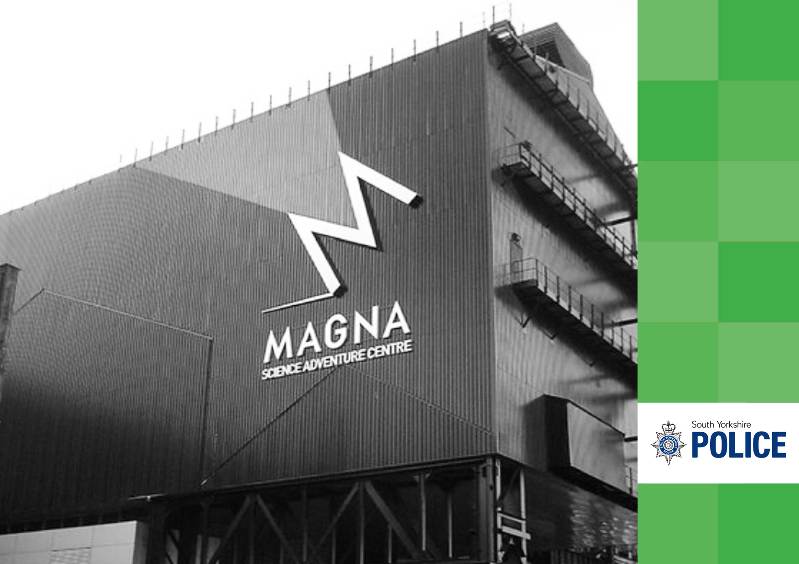
Magna Science Adventure Centre

Note 23 Police Pension Fund Account and a Net Assets Statement
2024/25  From 7 May |  | 2025/26
£’000 |  | £’000
 | Current Assets
- | - Amount owing from General Fund | -
- | - Year-end creditors | -
- | - Pensions paid in advance | -
- | Total | -

2024/25 from 7 May |  |  | 2025/26
£’000 | £’000 |  | £’000 | £’000
 |  | Contributions Receivable
 |  | From the SYMCA
(39,175) |  | - Normal | (45,407)
(188) |  | - Early Retirements | (1,324)
(14,955) |  | Officers’ Contributions | (17,722)
(1,377) |  | Abatement Contributions | (831)
 | (55,695) |  |  | (65,284)
 | (575) | Transfers in from Other Schemes |  | (495)
 |  | Benefits Payable
88,335 |  | - Pensions | 100,895
13,152 |  | - Commutations and lump sum retirement benefits | 18,829
154 |  | - Death benefits | 184
 | 101,641 |  |  | 119,908
 |  | Payments to and on account of leavers
113 |  | - Refunds of contributions | 139
74 |  | - Transfers out to other Schemes | 235
 | 187 |  |  | 374
 | 45,558 | Net Amount Payable for the year |  | 54,503
 | (45,558) | Additional Contribution from the SYMCA (via Home Office) |  | (54,503)
 | - | Additional Contribution from the SYMCA |  | -
 | - | Net Amount Payable / Receivable for Year |  | -

Note 23 Police Pension Fund Account and a Net Asset Statement (continued)

The Police Pension Fund Account is operated in accordance with the Police Pension Fund Regulations 2007 (SI 2007 No 1932), which specifies the amounts that must be paid into and out of the Fund. The Chief Constable administers the Fund Account on behalf of the SYMCA although no cash is transacted by the Chief Constable, with all payments and receipts being made by the SYMCA.

An employer’s contribution is paid into the fund, together with contributions from employees who are members of the Police Pensions Schemes. The contribution rates are based on percentages of pensionable pay, as determined nationally by the Government and subject to triennial revaluation by the Government Actuary’s Department. The current contribution rates are:-

- 2015 Scheme = 47.74% to 49.08% (35.30% for the employer and 12.44% to 13.78% for employees).

The actuarial valuation has set the employer contribution rate for the police pension scheme from 1 April 2025 at 35.30% of pensionable pay.

On 31 March 2022, the 1987 & 2006 Scheme were closed which means that from 1 April 2022, there is only the 2015 pension scheme which is open.

Payments are also made into the Fund in respect of ill health retirements.

The schemes are unfunded which means that there are no investment assets built up to meet pensions payments.

The Pension Fund Account is therefore balanced to nil each year by a transfer from the SYMCA’s General Fund, which then receives a top-up grant from the Government if contributions are insufficient to meet the defined pensions benefits payable. Any surpluses on the Fund are repayable to the Government.

The accounting policies adopted for the Pension Fund follow those set out in the Statement of Accounting Policies (Note 18). However, the Net Assets Statement does not include liabilities to pay pensions and other benefits after the Balance Sheet date. These are dealt with within the Group Financial Statements in accordance with the applications of International Accounting Standard 19 – Retirement Benefits.



Sheffield Cathedral
6. Glossary
and contacts

Glossary of Terms

ACCOUNTING POLICIES

The rules and practices adopted that determine how the transactions and events are reflected in the accounts.

ACCRUALS

The concept that income and expenditure is recognised as it is earned or incurred, not as cash is received or paid.

ACTUARIAL GAINS AND LOSSES

The change in actuarial deficits or surpluses that arise because either events have not coincided with the actuarial assumptions made for the last valuation (experience gains or losses), or because the actuarial assumptions have changed.

AMORTISATION

The writing down of an asset over a period of time in order to charge the revenue account for the usage of the asset.

ANNUAL GOVERNANCE STATEMENT

The annual governance statement is a statutory document that explains the processes and procedures in place to enable functions to be carried out effectively.

ASSETS

Items of worth, which are measurable in monetary terms. Current assets are ones that change in value on a day-to-day basis whereas fixed assets are assets, which yield benefit to the SYMCA for a period of more than one year.

BUDGET

A statement defining in financial terms the SYMCA’s plans over a specified period. The budget is prepared as part of the process for setting the precept.

CAPITAL EXPENDITURE

Spending on the acquisition of assets or spending which adds to and not merely maintains the value of an existing asset. Payments for the acquisition, construction, enhancement or replacement of assets such as land, buildings and computer equipment.

CAPITAL FINANCING REQUIREMENT

This measures the underlying need to borrow for capital purposes.

CAPITAL RECEIPTS

Proceeds from the disposal of land or other capital assets, which may be used to reduce debt or to finance capital expenditure but cannot be used to support revenue expenditure.

CIPFA (CHARTERED INSTITUTE OF PUBLIC FINANCE AND ACCOUNTING)

The accounting body that provides accounting guidance to the public sector. The guidance provided by CIPFA is defined as proper accounting practice and has statutory backing.

COMPREHENSIVE INCOME AND EXPENDITURE STATEMENT

A statement which details the total income received and expenditure incurred during a year in line with IFRS reporting as required by the Code.

CONTINGENT ASSET

An asset arising from past events, whereby its existence can only be confirmed by one or more uncertain future events not wholly within the control.

CONTINGENT LIABILITY

A possible liability at the balance sheet date which will only be confirmed following the outcome of uncertain future events.

CREDITOR

Amounts owed by the SYMCA for works done and goods or services received for which actual payments have not been made as at 31 March.

CURRENT SERVICE COST (PENSIONS)

This measures the increase in the present value of pension liabilities generated in the financial year by employees. It is an estimate of the true economic cost of employing people in the financial year, earning service that will eventually entitle them to the receipt of a lump sum and pension when they retire.

DEBTOR

Amounts due to the SYMCA for works done and goods or services supplied for which actual payments had not been received as at 31 March.

Glossary of Terms (continued)

DEFINED BENEFIT PENSION SCHEME

Retirement benefits are defined independently of the contributions payable, and benefits are not directly related to the investments of the scheme. The scheme may be funded or unfunded.

DEPRECIATION

The measure of the wearing out, consumption or other reduction in the useful life of a fixed asset arising from age, wear and tear, deterioration or obsolescence.

EARMARKED RESERVES

Amounts set aside for a specific purpose in one financial year and carried forward to meet expenditure in future years.

EXCEPTIONAL ITEMS

Material items which derive from events or transactions that fall within the ordinary activities, which need to be disclosed separately by virtue of their size or incidence to give a fair representation in the accounts.

EXPECTED RETURN ON ASSETS (PENSION)

This is a measure of the average rate of return expected on the investment assets held by the scheme for the year. It is not intended to reflect the actual realised return on the scheme, but a longer-term measure, based on the value of assets at the start of the year and an expected return factor.

FINANCE LEASE

A lease that transfers all the risks and rewards of ownership of a fixed asset to the lessee. Assets held in this way by the SYMCA appear on the SYMCA’s Balance Sheet and are accounted for as property, plant and equipment.

FINANCIAL INSTRUMENT

This is any contract that gives rise to a financial asset of one entity and a financial liability of another. The term covers both financial assets such as loans receivable and liabilities such as borrowings.

GENERAL FUND BALANCE

The General Fund Balance is the description given in the Code to those reserves held by the SYMCA that are not earmarked for specific purposes and is more commonly described as General Reserves.

GOVERNMENT GRANTS

Assistance by Government and inter-governmental agencies and similar bodies in the form of cash or transfers of assets to a SYMCA in return for past or future compliance with certain conditions relating to the activities of the SYMCA.

GROSS BOOK VALUE

The value of an asset before deducting depreciation and impairment.

IMPAIRMENT

A reduction in the value of a fixed asset below its carrying amount on Balance Sheet.

INTANGIBLE FIXED ASSETS

These are fixed assets such as software licences that do not have physical substance but are identifiable and controlled through legal or custody rights.

INTEREST COSTS (PENSIONS)

The expected increase in the present value of liabilities during the year as they move one year closer to being paid.

LIABILITIES

Amounts due to individuals or organisations, which will have to be paid at some point in the future. Current liabilities are usually payable within one year of the balance sheet date.

MINIMUM REVENUE PROVISION

The statutory minimum amount that must be set aside from revenue each year to repay debt. A prudent level is set by the SYMCA.

NET BOOK VALUE

The amount at which fixed assets are included in the Balance Sheet, that is their historical or current value less the cumulative amounts provided for depreciation.

OUTTURN

Actual income and expenditure for the financial year.

PAST SERVICE COST (PENSIONS)

These costs represent the increase in liabilities arising from decisions taken in the current year to improve retirement benefits, but whose financial effect is derived from years of service earned in earlier years.

Glossary of Terms (continued)

PRECEPT

An amount of money levied by one body (the precepting body) which is collected by another authority (the collecting authority) as part of the council tax. The SYMCA is the precepting body and the four South Yorkshire District Councils are the collecting authorities.

PRIOR YEAR ADJUSTMENT

A material adjustment applicable to prior years arising from changes in accounting policies or correction of fundamental errors.

PROVISIONS

Sums set aside to cover a liability that is likely to be incurred, but the amounts or date on which the cost will arise is uncertain.

PRUDENTIAL CODE

Local authorities are required to comply with the Prudential Code for Capital Finance in Local Authorities, published by CIPFA, in order to ensure that their capital investment plans are prudent, affordable and sustainable.
PUBLIC WORKS LOAN BOARD

A Government controlled agency that provides a source of borrowing for public authorities.

RESERVES

An amount set aside for a specific purpose in one financial year and carried forward to meet expenditure in future years.

REVENUE EXPENDITURE

Expenditure on day-to-day running costs incurred by the SYMCA in the provision of services.

TREASURY MANGEMENT

The management of the SYMCA’s investments and cash flows, its banking, money market and capital market transactions; the effective control of the risks associated with those activities; and the pursuit of optimum performance consistent with those risks.

Acronyms and Abbreviations

ACPO | Association of Chief Police Officers
AGS | Annual Governance Statement
BME | Black and Minority Ethic
CARE | Career Average Revalued Earnings
CC | Chief Constable
CDA | Crime Data Accuracy
CDI | Crime Data Integrity
CFR | Capital Financing Requirement
CIES | Comprehensive Income and Expenditure Statement
CIPFA | Chartered Institute of Public Finance and Accountancy
CPI | Consumer Price Index
CSE | Child Sexual Exploitation
CSP | Community Safety Partnership
CSR | Comprehensive Spending Review
EUV | Existing Use Value
FTE | Full Time Equivalent
GAD | Government Actuaries Department
HMICFRS | His Majesty’s Inspector of Constabulary and Fire & Rescue Services
IAS | International Accounting Standards
IFRS | International Financial Reporting Standards
JIAC | Joint Independent Audit Committee
LASAAC | Local Authority (Scotland) Accounts Advisory Committee
LCJB | Local Criminal Justice Board
LGPS | Local Government Pension Scheme
MHCLG | Ministry of Housing, Communities and Local Government
MOJ | Ministry of Justice
MRP | Minimum Revenue Provision
MoPI | Management of Police Information
MTRS | Medium Term Resource Strategy
NPCC | National Police Chiefs Council

NRE | Net Revenue Expenditure
ONS | Office for National Statistics
OPCC | Office of the Police and Crime Commissioner
PAB | Public Accountability Board
PCC | Police and Crime Commissioner
PCS | Police Compensation Scheme
PEEL | Police Effectiveness, Efficiency and Legitimacy
PPS | Police Pension Schemes
PWLB | Public Works Loans Board
QPR | Quarterly Performance Review
RICS | Royal Institution of Chartered Surveyors
SCR | Strategic Concern Register
SCT | Senior Command Team
SOLACE | Society of Local Authority Chief Executives and Senior Managers
SYMCA | South Yorkshire Mayoral Combined Authority
SYP | South Yorkshire Police

Contact Information

This document gives details of CC’s Annual Accounts and is available along with more information about finances on its website at www.southyorkshire.police.uk

CONTACT FOR FURTHER INFORMATION:

The Chief Finance Officer

South Yorkshire Police
Carbrook House
5 Carbrook Hall Road
Sheffield
S9 2EH

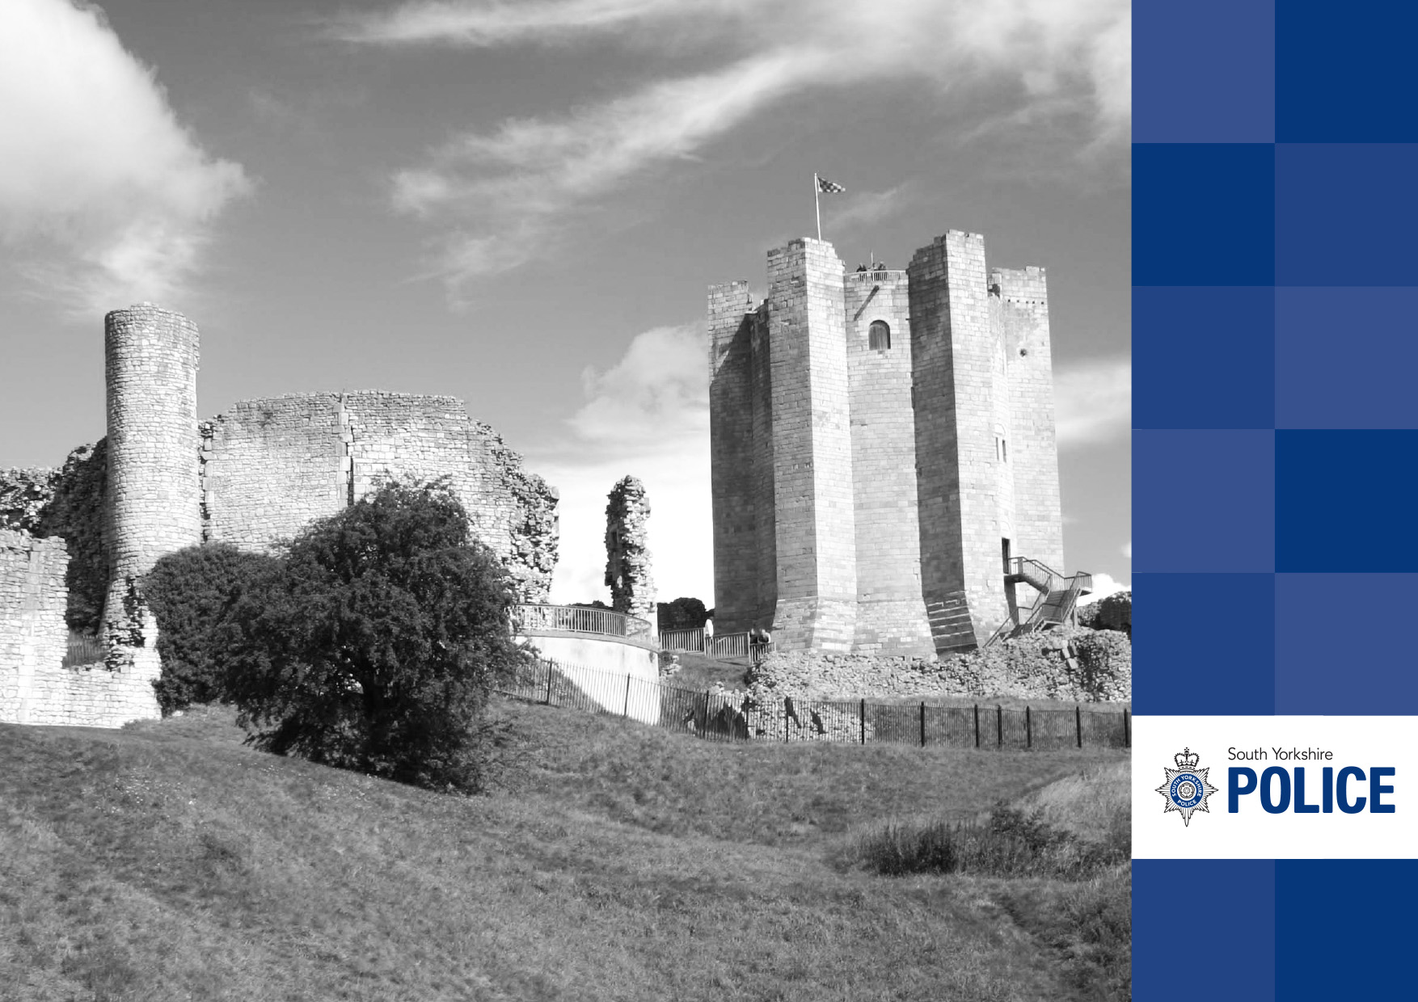
Conisbrough Castle

