Packaging a Mobile Phone or Computer/Laptop/Tower Unit for HTCU

All Mobile Phones should be placed in a cardboard Box and then either in a serial numbered evidence bag with an incorporated exhibit label (see Fig. 1) or a clear plastic bag with a serial numbered tie seal and an exhibit label attached to the outside of the sealed bag. (See Fig. 2).
Mobile Phone packaged in a cardboard box and sealed in an evidence bag.
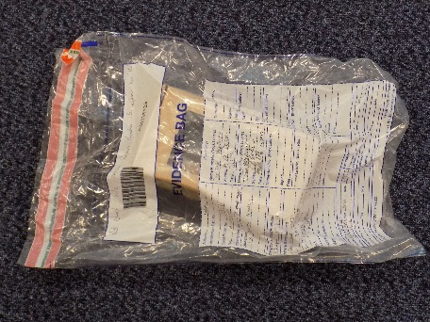 | 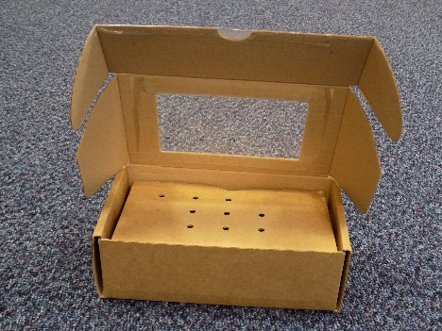 | 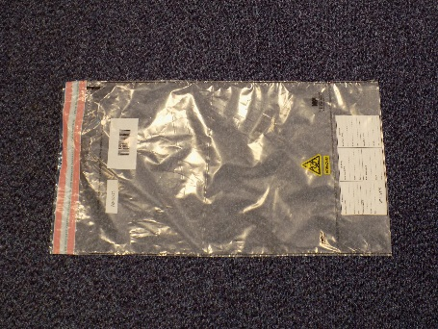
Fig. 1
Mobile Phone packaged in a cardboard box in a clear plastic bag.
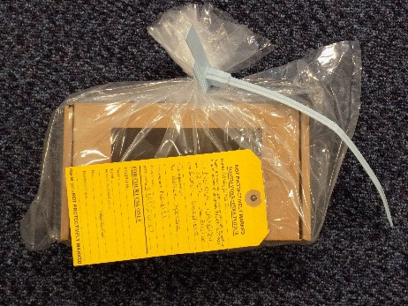 |  | 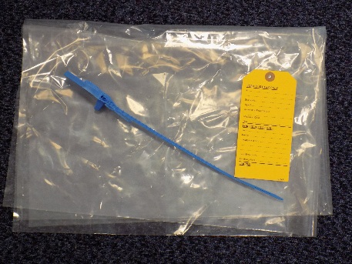
Fig.2

All computers/Laptops/Tower Units can either be in a clear plastic bag secured by a serial numbered tie seal and an exhibit label attached to the outside of the sealed bag or a serial numbered evidence bag with an incorporated exhibit label. (See Fig. 3)
Computer Packaging options.
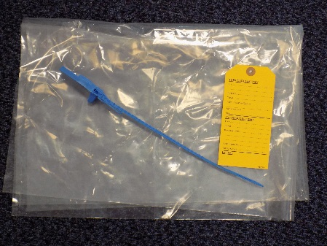 | 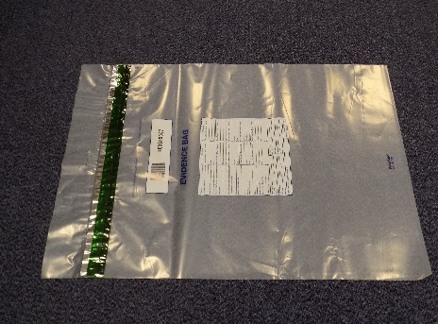
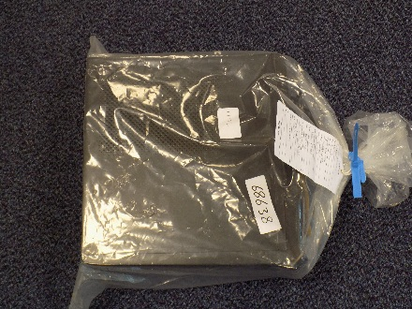 | 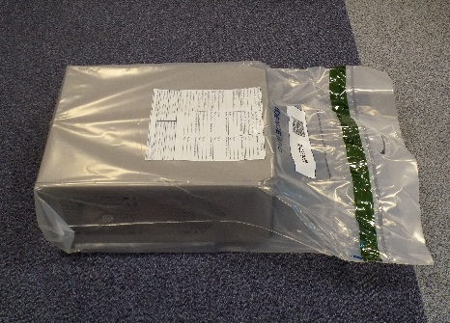
Fig. 3

